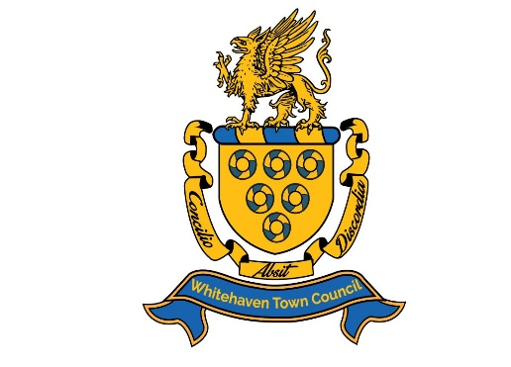

**PUBLIC NOTICE**

**Whitehaven Town Council**

**NOTICE IS HEREBY GIVEN** there will be an **EXTRAORDINARY MEETING** of **WHITEHAVEN TOWN COUNCIL** called by Councillor Edwin Dinsdale and Councillor Gemma Dinsdale at **CIVIC HALL, WHITEHAVEN** on **THURSDAY 20th February 2025** at **6:00pm**

The Meeting is to discuss the orange/brown water pollution in Whitehaven Harbour

Members of the public and press are welcome to attend.

Hard copies of the agenda can be sent out on request. It is also available to view on the Council’s website at: [www.whitehaventowncouncil.co.uk](http://www.whitehaventowncouncil.co.uk)

Councillor Edwin Dinsdale

Councillor Gemma Dinsdale