

**WHITEHAVEN TOWN COUNCIL**

**Clerk and Responsible Financial Officer:** Marlene Jewell

Telephone: 01946 67366

**Chairman:** Councillor G Roberts

To: **Members of Whitehaven Town Council**

You are duly **SUMMONED** to attend a **MEETING ofWHITEHAVEN TOWN COUNCIL** which will be held in **THE BEACON PORTAL** at **THE BEACON, WHITEHAVEN on Thursday 30th January 2025 at 6.00 pm**

Signed.\r'.:-.Q.:-;-:U: -.-.. Dated.. - :-J.. 9.S

Marlene Jewell, Clerk and Responsible Financial Officer

##### AGENDA

1. **Apologies for Absence**
2. **Declarations of Interest**

To receive declarations of interest by elected Members in respect of Agenda items.

If a Member requires any advice on any item involving a possible declaration of interest which could affect his/her ability to speak and/or vote he/she is advised to contact the Clerk at least 24 hours in advance of the meeting.

1. **Public Participation**
2. **Minutes of Council Meeting held on28th November 2024**
3. **Minutes of Extraordinary Council Meeting held on 13th January 2025**
4. **Planning Applications**
5. **Meeting with Home Group**
6. **Report from Cumberland Council**
7. **Finance Report**

1. **Consultation on Cycling a.11.dWall<lng m Wliitelia.ven, Bus Services and Car Parks**
2. **Easter Egg Event**
3. **Quote received from Octopus Energy**
4. **WCSSG-** Councillor E Dinsdale to give a report
5. **Christmas Lighting** - Report to follow
6. **Councillor Ward Matters**
7. **Date and Time of Next Meeting**

##### IN PRIVATE

That prior to the following items of business the Chairman will move the following resolution:

That in view of the special or confidential nature of the business about to be transacted it is advisable in the public interest that the public and or press be instructed to withdraw.

1. **Office Renovation update** - to follow
   1. Clerk to give an overall report
   2. To consider unforeseen repairs approved at the October Council Meeting
   3. To consider the overall Project Financial Position

### WHITEHAVEN TOWN COUNCIL

**Minutes of the Council Meeting held on the 28th November 2024**

**Present:** Councillor C Hayes (Deputy Chairman in the Chair); Councillor B O'Kane; Councillor A Pearson; Councillor A Spedding; Councillor R White

M. Jewell, Clerk and Responsible Financial Officer

V. Gorley, Assistant Clerk

Michael Barry, Assistant Director of Inclusive Growth and Placemaking­ Cumberland Council

Councillor M Hawkins - Cumberland Council Councillor J Ghayouba - Cumberland Council Councillor G Minshaw - Cumberland Council Members of the Public

Prior to the Meeting starting the Deputy Mayor asked all Town Councillors

present to introduce themselves.

He informed all those present that there was no scheduled testing of the fire Alarms and gave evacuation details should the fire alarm ring.

He explained about public participation and gave information about conduct at Meetings

The Clerk said that she had been contacted by Councillor Roberts who had asked that an update be read out. Councillor Roberts said in early November he had been admitted to West Cumberland Hospital for tests and after undergoing tests he had been discharged into the care of his GP.

**2659/24 Apologies for Absence**

Apologies for absence were received from:

Councillor G Roberts Councillor R Gill Councillor R Taylor Councillor **J** Carr Councillor R Redmond

illness illness Holiday Holiday Holiday

Councillor E Dinsdale Councillor G Dinsdale

Bereavement Bereavement

It was proposed by Councillor O'Kane and seconded by Councillor White that the apologies for absence be approved and signed by the Deputy Chairman as a correct record. A vote was held and it was unanimously

**RESOLVED** - That the apologies for absence be approved and signed by the Chairman as a correct record.

#### 2660/24 Declarations of Interest

Councillor Hayes declared that he was a member of the Whitehaven Tidy Town Group and the Harbour Users Group.

#### 2661/24 Public Participation

There was no public participation

#### 2662/24 Minutes of Council Meeting held on 31st October 2024

It was proposed by Councillor O'Kane and seconded by Councillor Hayes that the Minutes of the Council Meeting held on 31st October 2024 be approved and signed by the Chairman as a correct record. A vote was held and it was unanimously

**RESOLVED** - That the Minutes of the Council Meeting held on 31st October 2024 be approved and signed by the Chairman as a correct record.

#### 2663/24 Planning Applications

The Council considered a list of Planning Applications shown at Appendix 1. It was proposed by Councillor Hayes and seconded by Councillor O'Kane that following consideration of the Planning Applications on Appendix 1 that Cumberland Council be informed that the Council had no representations/comments to make. A vote was held and it was unanimolusly

**RESOLVED** -That after consideration of the Planning Applications on Appendix 1 that Cumberland Council be informed that the Council had no representations/comments to make

#### 2664/24 Report from Cumberland Council

Councillor Mike Hawkins from Cumberland Council attended. He said

* The Cenotaph revamp - he was pleased to see it had been done before Remembrance Sunday and now we needed to look at Stage 2. He said this was good news for joint working together
* The top half of Overend Road got reconstructed recently
* He said himself and Graham had met with Active Cumbria and this was funding that had come into the area from Sports England for 3 areas across the Country and we've got 2 of them -Mirehouse and Mirehouse/Greenbank, Workington and Maryport. This was not time limited funding and it was about listening to communities and about what the community wants.
* Children's services of Cumberland Council after many years of being adequate recently had an inspection and had been rated as good
* Public Realm - and asked if the Council had had a response from Michael Barry. Councillor O'Kane said Mr Barry had said he would be here at the meeting

Councillor Pearson raised the issue of Greenbank Play Park and said Home Housing had said they were happy to gift it back to the community but they had no funds. He said wouldn't it make sense for Cumberland Council to take it back into its ownership. Councillor Ghayouba replied and said there was a desire to bring play parks back in house where they could. He said Bransty didn't have a play park and recently they had done a review ofplayparks to try and get funding and in the case ofBransty a group with CIC status had been set up which allowed them to apply for grants and if Greenbank did that they may be able to get funding. Councillor Pearson said Greenbank was a deprived area and a lot of parents were not actively involved in the estate - they wanted somewhere for their kids to play. He said this play park provides a play area to keep the kids off the streets and it just needs to be brought back into repair. He said it appeared that Cumberland didn't want to take ownership of anything on Greenbank. He said for Home Housing to gift it back it was a gift of nothing and he thought Cumberland Council should step in and look after it.

Councillor Hawkins suggested that Home Housing could be asked if they would gift it back with some funding

Councillor Pearson said the playpark had not been vandalised it had been so

well used it was worn out.

Councillor Hawkins asked that as Michael Barry had arrived could Item 14 on the Agenda - Whitehaven Public Realm Scheme - be moved forward

The Chairman agreed to this



#### 2665/24 Whitehaven Public Realm Scheme

Councillor O'Kane thanked Michael Barry for attending and then made the following points

* We have talked about this a lot historically and he thought memories had differed about what had been said.
* The biggest problem in the future was working together because people were no longer just round the comer
* Originally when we talked about the Public Realm before the pandemic we all met in the United Reformed Church and we went round the Town and the outcome was that whatever we suggested ended up back at the Green Market. We also had ideas about stringing banners across the top of Lowther Street and putting blocks at the top end of King Street that said King Street. Because we had lost the toilets
* We had a follow up meeting about 2 months later when he had asked one question "whatever Public Realm activity that comes how will this bring £1 to the centre of Whitehaven". At the time the feedback that the Town Council was having was that there wasn't one of the Town Council in favour of moving on the Green Market. We were totally against that but we talked about other things - toilets were always on the agenda because we had lost the toilets. At that point everything stopped and Millom started to go ahead, Egremont ended up in abeyance.
* Then came the pandemic and we were very aware that we had some Public Realm money in the Town Council's bank and we were hoping to try and rejuvenate some kind of scheme and in our heads there was £50,000 toward trying to build toilets in the Town but Copeland eventually moved away from the toilet idea. So at that point we worked with them to paint the gazebo on the Green Market and we put flowers in and later on Copeland put benches in to tidy the area up.
* Then there was another meeting to discuss the new Public Realm funding led by BEC and for an hour and a half we spoke about the digitalisation of the Town and that was high on their agenda. BEC asked the question why the money was being organised and run by the County Council and not the Town council where the money was going to be spent. That was pushed aside quickly.
* We then talked about public toilets. We were aware that this wasn't a together meeting - there were various vested interests from other groups there. By the end of the meeting - the last five minutes - suddenly the Green Market cropped up and was brought up by the lady in charge and immediately we asked what was going to happen to the traders already there. The promise was that all details of expenditure and the rules of engagement would be provided to us. That never happened. At the end of the meeting we were given the quick precis by the gentleman who was there and he gave us copies of what he thought would be on the Green Market which included things like lights in the ground.

* At the next meeting I couldn't attend in person but attended by zoom for 10 minutes at the time the meeting was debating the toilet situation. The rest of the meeting according to what I was told- the Green Market was the focus of the discussion and then somebody brought in the top end ofKing Street to make it more attractive. So there were two areas in town - one near the market area and the other one at the top (Duke Street) where you have cars passing the comer going to Tesco all day and yet somebody said we want to make that area more attractive
* We have now got £450,000 bearing in mind we are renovating our building and our whole building (the old Whitehaven News building which is massive) and in the end will be a community facility and which is costing us about £800,000 and compared to £450,000 which is being spent on 6 benches, 5 trees, a couple of information boards and cleaning of the ground areas that are there. He said the question was again what will those areas bring to Whitehaven.
* Councillor O'Kane referred to the two traders on the Green Market and said if those 2 traders were put in King Street there would be trouble as they would be putting them in competition with shops who were paying a lot of money and also all the accesses to King Street would presumably have to be changed
* The other alternative to move the 2 traders further down the market outside Kinsellas. To move them any further down the market and that would be them finished as the footfall there would be much less than in the Green Market. Also these alternatives would necessitate the whole area of the market place to being closed off to traffic in accordance with the road traffic order.
* Very little would be brought to our Town for this amount of money

Michael Barry said he was there to listen and the email sent to Councillors was just to give the journey we've been on so far. He made the following points:

* We are trying to enhance the character of Whitehaven Town Centre to be attractive to visitors coming in through the visual appearance of the Town.
* He recognised that this was not a comprehensive solution but they were keen to do a long term improvement for the Town and acknowledged that engagement needed to be worked on.
* He said they were also acutely aware of the need of a comprehensive plan for the Town.
* The Traders were a complex picture and they were trying to regularise their

status and were working with them positively to find a suitable location

* They recognised that the market had ceased in Whitehaven and they needed to look at how they wanted to bring elements like markets back which could enhance the vibrancy of the Town. Across the board they were getting messages that they needed to provide newer, better and innovative things for the Town. But they had a challenging situation they had to sort out with the tradesmen

Councillor O'Kane said this would cause conflict with the traders as what was being said was that the idea was fixed and it was always going to be the Green Market and asked why they had even had several meetings on this. He asked what this was going to give our Town. He said this was making us all look a laughing stock because people don't differentiate between Cumberland Council and the Town Council.

Councillor O'Kane said Copeland Council had already funded benches which

were in the Green Market and we would get criticised over this.

Councillor Pearson said toilets had been on the agenda for a long time and it was something that was needed.

Councillor O'Kane referred to the cenotaph as an example of working together

where the Town council immediately agreed to chip in because we want our Town bettered

Councillor Hayes said the MP did a survey and all people asked him about

toilets.

Councillor Ghayouba said shopkeepers main gripe was the footfall and that it was not pedestrian friendly in any way at all. Most people have a routine - they go to Tesco or Morrisons walk up the Harbour and go to the Howling wolf for a coffee and walk back to the car when the 2 hours is up. They don't think to venture down towards King Street and he thought it was schemes like this where they were looking to make elements of King Street more inviting.

Councillor Ghayouba said it was a start and we need to think that this effort being done by Cumberland Council is being done by the current administration of Cumberland Council to make Whitehaven a priority. Councillor Fryer had said it was Whitehaven's turn to get a real amount of investment and try and get some stuff to turn the fortunes around. We need to do something and we also need to look at the bigger picture. But this is the start

Councillor O'Kane said his criticism of this issue was working together and what had happened was not working together at all and that this had never happened

Michael Barry referred to the cost and said it was about quality of

materials and quality of finishings and the cost reflected this. He said it was consistent with the style standard used elsewhere. He asked how do we get some transformative investment for the Town.

He said it was important that quality investment for the Town was delivered.

Anything that makes the Town more attractive and inviting is good.

He said this is a quality pocket of intervention. There were three sides to this­ capital investment, the animation and attractiveness

He said there were real opportunities moving up and that it was expensive

because it was quality

Councillor Ghayouba said the Government had given them powers to lease out properties where they have stood empty

Councillor O'Kane said what was getting to him was that it had been like cloak

and dagger all the way along and he hoped that things would improve in the future

Councillor Ghayouba said in the next 5 or 6 years there was Whittles building

that would hopefully be fully complete. He said the former Park Nightclub was an eyesore. It is about little stages and phases and generally we do try to keep everyone in the loop and not exclude people. He said that all this predated all ofus here and we will do better on engagement and collective working in the future and we take on board Councillor O'Kane's criticism

Councillor Hawkins said the streetscape Scheme would fit in nicely with this and you need everything to match

The Deputy Chairman thanked everyone for attending

**2666/24 Finance Report**

The Council considered the Finance report

1. Appendix 1 - The Assistant Clerk reported that there were 5 additional invoices to consider on Appendix 1 namely:-

Julie Hartley £500 Internal Audit Fee

Logan Paul Murphy £t595 Christmas Lights Fee

J & R Bennett £1,779.20 Winter Plants

J & R Bennett £4,450.80 St Nicholas Winter Plants

J & R Bennett £6,912.50 St Nicholas Plants and Maintenance

It was proposed by Councillor Hayes and seconded by Councillor O'Kane that the invoices shown on Appendix 1 plus the 5 extra invoices be approved and paid. A vote was held and it was unanimously

**RESOLVED** - That the invoices shown on Appendix 1 plus the 5 extra invoices be approved and paid.

ii. Appendices 2 and 3 - It was proposed by Councillor Hayes and seconded by Councillor O'Kane that Appendices 2 and 3 be approved and noted. A vote was held and it was unanimously

**RESOLVED** - That Appendices 2 and 3 be approved and noted.

**2667/24 Internal Auditor's Report**

The Council considered the Internal Auditor's Interim report.

The Chairman said he would like to say many thanks to our 2 Clerks for all the hard work they had put in during the last 12 months

It was proposed by Councillor Hayes and seconded by Councillor O'Kane that the Interim Report be accepted and approved. A vote was held and it was unanimously

**RESOLVED** - That the Interim Report be accepted and approved

**2668/24 Quote Received for the Provision of Internal Auditor**

The Council considered a report on an annual quote received of £600 for the provision of an Internal Audit Service to the Council for 2025/26 and considered whether or not Financial Regulations should be suspended in order to accept the quote and considered the risks and reasons in 2.3 and 3.2 of the

Report. It was proposed by Councillor Hayes and seconded by Councillor White that (i) a resolution be made to suspend Financial Regulations

to allow the quote of £600 to be accepted and (ii) that having made the resolution

that the reasons for the suspension be recorded and the assessment of the risks be accepted and approved. A vote was held and it was unanimously

**RESOLVED-That** (i) a resolution be made to suspend Financial Regulations to allow the quote of £600 to be accepted and (ii) that having made the resolution that the reasons for the suspension be recorded and the assessment of the risks be accepted and approved.

**2669/24 Quote received for the Erection. Maintenance. Dismantling and Repair of Christmas Lights in Whitehaven 2025/26**

The Council considered a report containing a quote of £24,500.00 plus VAT for the erection, maintenance, dismantling and repair of the Christmas Lights in Whitehaven 2025/26 and considered whether or not to suspend Financial Regulations to allow the quote of £24,500.00 plus VAT to be accepted and considered the risks and reasons in paragraph 1.3 of the Report. It was proposed by Councillor Hayes and seconded by Councillor O'Kane that (i) the Financial Regulations be suspended in order to accept the quote of £24,500.00 plus VAT and (ii) that having made the resolution the reasons for the suspension be recorded and the assessment of the risks be accepted and approved. A vote was held and it was unanimously

**RESOLVED** - That (i) the Financial Regulations be suspended in order to accept the quote of £24,500.00 plus VAT and (ii) that having made the resolution the reasons for the suspension be recorded and the assessment of the risks be accepted and approved.

**2670/24 Quote received for the Erection, Maintenance and Dismantling of Bunting in Whitehaven 2025**

The Council considered a report containing a quote of £4,446.91 plus VAT from Cumberland Council (same as last year) for the erection and dismantling of bunting in Whitehaven, The Council considered whether or not to suspend Financial Regulations to allow the quote of £4,446.91 plus VAT to be accepted and considered the risks and reasons in paragraphs 1.2 of the report. It was proposed by Councillor Hayes and seconded by Councillor O'Kane that (i) the

Financial Regulations be suspended in order to accept the quote of £4,446.91 Plus VAT and (ii) that having made the resolution the reasons for the suspension be recorded and the assessment of the risks be accepted and approved

**RESOLVED** - That (i) the Financial Regulations be suspended in order to accept the quote of £4,446.91 plus VAT and (ii) that having made the resolution the reasons for the suspension be recorded and the assessment of the risks be accepted and approved

**2671/24 WCSSG** -Report by Councillor E Dinsdale

No report was given as Councillor E Dinsdale was unable to attend the Meeting

#### 2672/24 Christmas Closing

The Council considered a report on options for the Council's Christmas Closing hours. It was proposed by Councillor Hayes and seconded by Councillor White that the Council close for business on Friday 20th December 2024 and reopens on Monday 6th January 2025. A vote was held and it was unanimously

**RESOLVED** -That the Council close for business on Friday 20th December 2024 and reopen on Monday 6th January 2025.

#### 2673/24 Whitehaven Public Realm Scheme

This was item 14 on the Agenda but by agreement had been brought forward and dealt with after the Report from Cumberland Council

#### 2674/24 Councillor Ward Matters

1. Councillor White referred to 8 Corkickle a residential property which had a change of use to an air bnb. In the application this was applied for together with one parking space on Corkickle. However he had received complaints since of said house having several parking spaces for use and on the streets thus complicating things for permanent residents there including cars to the side of which some may have it is alleged no tax or MOT or insurance and there is an allegation that alcohol is being sold on the property with a temporary licence which would require change of use for that building as it is in a residential area. He recommended that Councillors think twice in the future about changes of hands from properties from a private dwelling to a holiday let and also recommends the investigation of this property.



1. Councillor O'Kane asked if there was a Home Group Meeting that month. He said he had tried emailing James several times but had got nothing back. Councillor White said he had heard nothing
2. Councillor O'Kane said if you come out of Whitehaven at the Pelican Garage there is permitted parking on the right hand side and if you want to turn right you've got traffic coming at you and it was only a matter of time before there was a smash. Councillor Ghayouba said as part of the TRO there was to be yellow lines there. On all 3 junctions there there will be double yellow lines

1v. Councillor Hayes said at the weekend the Christmas Fayre at Kells was well attended and there was a visit from Santa

1. Councillor Hayes said he had received a report that night that there was 2 cars with their windows smashed in by bricks. They were advised to report this to the Police and the Police are now looking into it
2. Councillor Pearson made the following points
   * The grass on no mans land which is a 10 foot strip of grass has been cut but they still hadn't cut the footpath that keeps people off the main road from Whitehaven to St Bees
   * 3/10/24 a gentleman called Bob Lancaster picked up on the

speeding on Greenbank before 5. It was 30mph but the 30mph signs are like half a mile maybe more towards St Bees and there wasn't a reminder sign of30 coming into there on any lamp post or anything to tell them they were in a 30mph. There had been numerous accidents at the top ofMirehouse hill where there is nothing there to tell them they're in a 30mph.

* + 9/10/24 Emma Williamson said she was arranging a meeting re

the speed issue

* + 19/10/24 He reported the speed reminder sign
  + 22/10/24 He reported the street light on B5435. This was creating a black area and nothing was being done
  + He said the speed on that road was ridiculous

#### 2675/24 Date and Time of next Meeting

The next Town Council Meeting would be on Thursday 30th January 2025 at the Beacon Portal, Whitehaven at 6.00pm

#### 2676/24 IN PRIVATE

That prior to the following items of business the Chairman moved the following resolution:

That in view of the special or confidential nature of the business about to be transacted it is advisable in the public interest that the public and or press be instructed to withdraw. Councillor Hayes proposed this and Councillor White seconded this. A vote was held and it was unanimously

**RESOLVED** - That the public and or press be instructed to withdraw.

#### 2677/24 Update on Office Accommodation

The Clerk gave a report received from the Contractor on progress since the report to the Council Meeting in October as follows:

* The exterior paintwork was 60% complete
* The majority of the timber windows to the first floor have been successfully refurbished
* Continued with the metal stud work in preparation for plasterboards
* Main supporting wall to the ground floor has been demolished, foundations for steelwork dug and poured. Steelwork erected
* Party wall steelwork replaced. The old steel support needs to be grouted

m.

The Architect was putting together some design schemes for some of the work that was in the contract and as reported to the last Council Meeting there were certain works that had been discovered that we would have to seek reports

for and quotes for these were currently ongoing.

The Clerk reported that in accordance with the Internal Auditor's recommendation a budget, expenditure to date and projection of total expenditure should be prepared separately for monitoring purposes and presented to each Full Council Meeting and this will be done

It was proposed by Councillor Hayes and seconded by Councillor White that the work carried out by the Contractor be noted and approved together with the Architect's design schemes and the Internal Auditor's recommendation. A vote was held and it was unanimously

**RESOLVED** - That the work carried out by the Contractor be noted and approved together with the Architect's design schemes and the Internal Auditor's recommendation

#### 2678/24 Application for Councillor Ward Grant- HPAG

The Council considered an application from HPAG for a Councillor Ward grant of £350.00. Where as in this case there is no specific power to make a grant it can be done under s137 of the Local Government Act 172 and in order to do this the Council firstly had to be satisfied that there was a direct benefit to the area or part of the area, or to some or all of the inhabitants and secondly that the Council must ensure that the direct benefit accruing to its area or residents is commensurate with the expenditure incurred.

It was proposed by Councillor Hayes and seconded by Councillor White that as the conditions of s137 had been satisfied a Ward Grant of £350 be awarded

to HPAG. A vote was held and it was unanimously



**RESOLVED-That** as the conditions of s137 had been satisfied a Ward Grant of£350 be awarded to HPAG.

#### 2679/24 Application for Grant - WCS&R

The Council considered an application from WCS&R for a grant of

£1,000. It was proposed by Councillor Hayes and seconded by

Councillor White that a grant of £1,000 be awarded to WCS&R. A vote was held and it was unanimously

**RESOLVED-That** a grant of £1,000 be awarded to WCS&R

The Meeting Closed at 7.30pm

Chairman



### WHITEHAVEN TOWN COUNCIL

**Minutes of the Extraordinary Council Meeting held on the 13th January 2025**

**Present:** Councillor C Hayes (Deputy Chairman in the Chair); Councillor R Gill; Councillor B O'Kane; Councillor R White

M. Jewell, Clerk and Responsible Financial Officer

V. Gorley, Assistant Clerk Member of the Public

Prior to the Meeting starting the Deputy Mayor informed all those present that

There were no alarms being tested that night and indicated where the toilets were

**2680/25 Apologies for Absence**

Apologies for absence were received from:

Councillor G Roberts Councillor **R** Taylor Councillor J Carr Councillor R Redmond Councillor E Dinsdale Councillor G Dinsdale Councillor A Pearson Councillor A Spedding

illness illness

Work Commitments

Holiday

Family Commitment Family Commitment illness

Family Commitment

It was proposed by Councillor Hayes and seconded by Councillor White that the apologies for absence be approved and signed by the Chairman as a correct record. A vote was held and it was unanimously

**RESOLVED** - That the apologies for absence be approved and signed by the Chairman as a correct record.

**2681/25 Declarations of Interest**

Councillor Hayes declared that he was a member of the Whitehaven Tidy Town Group and the Harbour Users Group.

Councillor Gill declared that he was a member of Whitehaven Heritage Action

Group

**2682/25 Public Participation**

There was no public participation

**2683/25 2025/26 Whitehaven Town Council Revenue Budget and Precept**

The Council considered a report on the Council's Revenue Budget and Precept for 2025/26. The Assistant Clerk read out the full report to the Council.

The Council wished it to be recorded that in answer to a question from Councillor O'Kane the Clerk informed the Council that there had been no written representations/comments/objections received from any of the Councillors who were summoned to attend the Meeting and who could not attend the Meeting and who had submitted their apologies for absence.

Following a discussion on the Report it was noted that the Council Ward Grants budget had been reduced to £12,000.00 for one year only and that there had been an increase of0.0235% in the Town Council Precept for 2025/26 which would result in an annual increase of £1.66 per Band D property which equated

to £0.0319p per week. It was:-

1. Proposed by Councillor Hayes and seconded by Councillor Gill that the proposed 2025/26 Budget had been considered

**RESOLVED** -That the 2025/26 Revenue Budget and Precept had been considered

1. Proposed by Councillor Hayes and seconded by Councillor White that no amendments be made. A vote was held and it was unanimously

**RESOLVED** -That no amendments be made

1. Proposed by Councillor Hayes and seconded by Councillor O'Kane that subject to i and ii above that the 2025/26 Revenue Budget and Precept be approved
2. Proposed by Councillor O'Kane and seconded by Councillor White that the Chairman and the Clerk sign the Precept 2025/26 Form received from Cumberland Council to advise Cumberland Council of the approved Whitehaven Town Council Precept for 2025/26 to inform the setting of the overall Council Tax requirement for 2025/26. A vote was held and it was
3. **RESOLVED** -That the Deputy Chairman and the Clerk sign the Precept 2025/26 Form received from Cumberland Council to advise Cumberland Council of the approved Whitehaven Town Council Precept for 2025/26 to inform the setting of the overall Council Tax requirement for 2025/26.

The Meeting Closed at 6.30pm Deputy Chairman

**WTC 30/01/2025**

**Item 6**

Planning Application for Consideration by Whitehaven Town Council

Application Nmnber 4/24/2353/0Fl

4/24/2393/0F 1

4/24/2406/TPO

4/24/2401/0Fl

4/24/2411/0F 1

4/24/2416/0F 1

4/24/2422/0Al

Detail

Consultation on Additional/Amended Information: PROPOSED REAR EXTENSION AND RAISED PARKING AREA, INTERNAL ALTERATIONS & DEMOLITION OF EXISTING GARAGE

**31 HIGH ROAD, WIDTEHAVEN**

PROPOSED SINGLE STOREY OUTBUILDING (GARAGE)_WITH STEPS TO SUIT NEW GROUND LEVELS

**55 RANNERDALE DRIVE, WHITEHAVEN**

WORKS TO VARIOUS TREES WITHIN A CONSERVATION AREA

**CROW PARK WOOD, LOOP ROAD, WIDTEHAVEN**

DEMOLITION OF FORMER JOHN PAUL JONES PUBLIC HOUSE

**FORMER JOHN PAUL JONES PUBLIC HOUSE, DUKE STREET, WHITEHAVEN**

PROPOSED GARAGE (RETROSPECTIVE) **LAND ADJACENT TO 9 EARLS ROAD, WHITEHAVEN**

REPLACEMENT OF WINDOWS ON FRONT ELEVATION AND RETROSPECTIVE REPLACEMENT OF WINDOWS ON REAR ELEVATION

**32/33 DUKE STREET, WHITEHAVEN**

SCAFFOLDING BANNER

Application Number Detail

**6 DUKE STREET, WHITEHAVEN**

4/24/2426/0Fl

4/24/2430/001

4/25/2002/0Fl

4/25/2003/0L l

4/25/2004/0F 1

4/25/2012/TPO

CHANGE OF USE OF PART GROUND FLOOR FROM BANK TO CAFE/WINE BAR

**71 LOWTHER STREET, WHITEHAVEN**

OUTLINE APPLICATION FOR RESIDENTIAL DEVELOPMENT OF 27 DWELLINGS WITH DETAILS OF NEW ACCESS FROM EGREMONT ROAD AND ALL OTHER MATTERS RESERVED **LAND ADJACENT TO HENSINGHAM HOUSE, EGREMONT ROAD, WHITEHAVEN**

SINGLE STOREY EXTENSION TO THE REAR OF AN EXISTING BUILDING TO PROVIDE ACCOMMODATION FOR A DISABLED PERSON. EXISTING DRIVEWAY TO BE EXTENDED AND DROP KERB TO BE INSTALLED TO PROVIDE BETTER VEHICLE ACCESS

**90 BRANSTY ROAD, WHITEHAVEN**

PROPOSAL TO REMOVE EXISTING LATH AND PLASTER (AND PLASTERBOARD) CEILINGS ON ALL LEVELS WHICH VARIES THE LISTED BUILDING CONSENT REFERENCE 4/21/2364/0Ll GRANTED 24.11.2021 AND APPROVAL TO DISCHARGE CONDITION 5 OF THAT CONSENT REFERENCE 4/24/2294/DOC GRANTED 18/09/2024 **6 DUKE STREET, WHITEHAVEN**

SINGLE STOREY SIDE EXTENSION FOR FAMILY ROOM, ADDITIONAL BEDROOM AND FRONT PORCH

**45 MUNCASTER ROAD, WHITEHAVEN**

PRUNE TO REMOVE CROWN OF Tl, T2 AND T3 AND FELLING OF T4 - TREES PROTECTED BY A TREE PRESERVATION ORDER

Application Number Detail

#### JERICHO PLANTATION, IDLLCREST AVENUE, WHITEHAVEN

4/25/2013/TPO

FELLING OF A CONIFER TREE SITUATED WITHIN A CONSERVATION AREA

#### 12 CLITHEROE DRIVE, WHITEHAVEN

##### WTC 30/01/2025

**Item 9**

##### FINANCIAL REPORT

**Purpose of the Report**

Members are asked to note the payments listed at Appendix 1 as being paid to avoid any late payment fees and to consider a list of invoices for authorisation and payment as shown at Appendix 2 and approve the recommendations in paragraphs 3.1 and 3.2.

**1.0 . INTRODUCTION**

* 1. Note the payments listed at Appendix 1 as being paid to avoid any late payment fees due to there not being a Full Council meeting since 28 1 November 2024.
  2. Authorise the payment of all invoices as listed in Appendix

2.

1.2 The Council is asked to note the cashbook as reconciled with the bank account as shown at Appendix 3 together with income and expenditure at Appendix 4.

##### FINANCIAL POSITION

* 1. The bank reconciliation was carried out on 22nd January 2025. This shows a balance of £190,972.32. There are no payments waiting to be cleared.
  2. The balance in the deposit account is £677,587.08.

##### 3.0 RECOMMENDATION

* + 1. The invoices listed and shown in Appendix 1 be approved and authorised for payment.
    2. The Cashbook (Appendix 2) and the Income and Expenditure (Appendix 3) be noted.

**30/01/2025**



-

**Appendix 1**

**Invoices for Ratification by Whitehaven Town Council**

! S,3/N?S:e

**Detail**

GUl,i:le'.:iSTdVE!1'.tf 1Nf'-/i":·.'

**LI !Power**

! **Columni**

30/11/2024

Studio Horn Limited

Earmarked Reserves

; bl-ilit/2-0:24? •<i,9iJ\N JNSnViil.'sfM ,di,ii•;§rrii:ii:C::

02/12/2024 cQ tQZ:4:: :'

02/'12./2024

*,i<iMt,tii/2'4-'*

i 08/12/2024

:"Q?/lii/to2;,f

09/12/2024

"".b91li7:i0.24>

E.ON Next Energy

/:sH in /cd'in'ffiiihitU,;cei:i.t'fi:;t Newsquest

Seymot

:sb fP'.'rtUSfoeJ

':,$'UP£Tie :i(ll{Sery1 s·.1t.'r'

Premises

·,:f ;-ero1 \/2:'

Suppi1es and Services

;; i J¥t:!ct·6'.;,

3rd Party

f.R'a\itf

Events

-· ·..,.,;:,-:-

t1.Stl1ff' ii'ifpaf8h%;;.:;:/

irge for Storage Unit

£

55.31 I

.,..·id:f44'.tGA,,--iQ72.i'::i: ,?,'.;\,.·, '· -\\/I

s111LGA 1972

·-:.,?<Sifa:it$$(i'S72)*?.,.*

;-,::,:· r

, -seacch Eo.ioe Optim'",sa""'ti"-o,==c.

'f.i4'i.:Ptt'202

Allotment Maintenance Contract- Nov 2024

:l?0::1:1fri f8/fit202:4\j1(;

,. *'ii'* J;

,,,, £

21.00 5144 LGA 1972

><,S23·'.Sfrla'IJ';BQtaij,$';;"- Wfo rrftiri'is·1Act'-i9Qif'-,

s23 Small Holdings & Allotments Act 1908

,:\·r /itL·si4Zlifi5A" 7.iI.,,:,;:

£ 350.00

l'iO/

: 09/h!'.2024,, -

09/12/2024

· ;cµ7n,0e 1 ti:d.::,C6'!Jnl;ii

Zurich Municipal

Events

"i2iiiti:2-0. 41:l"·::·

**Pate**

i28/1112J

**tier**

< .· ;-0i: Ra'ar6fR:ece$i •:G , ;.,g

Studio Horn Limited

Cumberland Council

Premises

';.e,7£mi31oy'W /:A110W:iJ'ri&S\·' ' --

Earmarked Reserves

Additional premium fnr Pl for l"irPw,1nrk

!M"ti'.r:.tr'.eir

M m Hire - 28/11/2024

, \- ;;,, 1:; 'C6'ristffiafGr.fu!iei-.'R1iditi1-Aa r:t!SfoifC mp'a[gij,fiQin rvti>t:9£s:;Ali6Warf6:&:'

ingoing support and remedial work- Office Renovation Proiect

..,,.,, " ':f:}\\Electtlitfl'a·fge;fuEsit

Presenter Fee (part) on signing contract for 2025 Science Show

£ 165.06

'"'<

';£"'•·· ·o;;3'9t\:tl.rr: *'iS":-·0••*

£

84.00 I

--·

£ :,000.00

13/12/2024

31/12/2024

*,dBQ.'•10?* ,C.-',<-

Deborah McKenna Ltd

£

1 650.00 I

s144 LGA 1972

_,_.,.·;:,:·\,.':;',"?';,

s144 LGA 1972

'si'4,4.t-GA I972/'.'':

s111LGA 1972

<, .,_ ,,fSiMiGA'-l t-2/,;

:/ilfa'.'t'GA'!1!§.'z;i'J<··, s144 LGA 1972

Eannarked Reserves

£ 656.40

1ft!_:/• ;;·;4-;somoa::

4mc

600.00

£

'

I 221011202s

/oe)dt/20,25)1

£ 23,465.06

**30/01/2025**

**Appendix2**

**Invoices for Consideration by Whitehaven Town council**

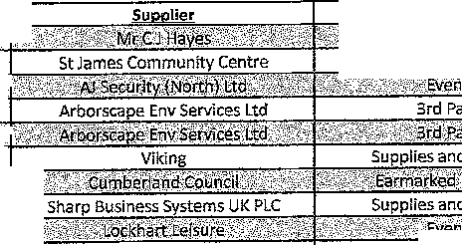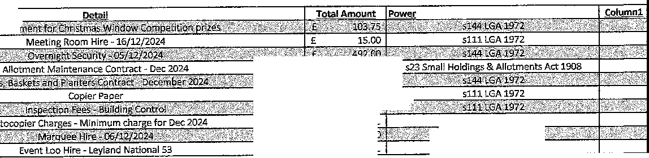

Cat

'{*inP1tw@f&\ijUbWffeiEeskff''-

Premises

1tc:tJ e:liin_uur:ser

£

656.40

services

£

47.82

';;£;1: Z ·2- ':l';$00ictO:J:.·: l-'.'-"'

Services

£

30,00

16[01/2025

Lakes Loos

Events

£

432.00

s111LGA 1972

,;·uhii44-'tGR;J·97,4(.•

s144 LGA 1972

**Date**

l<P'sJ:l].726 :T"''·

£ **10,680.97**

WHITEHAVEN TOWN COUNCIL

CASH 8001\ FROM l APRIL 2014

APP!!NDIX 3

Unpresented

w,

cheques as of Employees/ Supplies/ Ground Civic Environmental

VAT Total Min. Ref,

Date Ref Payae 31,03.24 Allowances Premises Services 3rd Party Grants Allotrnts Maint Hosplta1tty Ra1'1ger/SO W.I.B Grants Elections Improvements Events Contlngencies Reserve Net Total

Aprtl-2024

Unpre&erited chectues b/fwd from 2023/2024 18000.00

1$,000.0() 111,000,00 carried f/wrl

i.,351'l,/J3 £ 2,3511.8,3 24519/24

'

02.04.2024 1193 Cumberland Council 2391.133

02JJ4,W:l.4 ll,94 Cumberland council 12100.75

12,100.75 12,100.75 2499/24

767,57 £ 153,51 921,0B Col'ltr11ct

02.04.2024 DD Northern Trust Companv Ltd 767.57 '£ 10.08 10.08 contract

4 03,04,:W211 DD W11terPIUs 10.08

'

**5** 15,04,2024 DD Crown Gus IA Power 554,70

554.70 £ 110,94 665,M Contrnit

794.04 794.04 631/17 (11)

1$,04,2024 **8ACS** Cumbria LGPS 7911.04

15,04.2024 **BACS** St11fr 5508,78

15,04,2024 "'" HMRC 2253.01

5,508,78 £ 5.$08,78 2424/23

2,25:S.Dl £ 2,253,01 l-lMRC

800,00 800.00 £ 160,00 £ 960,00 24n/24

159,80 '

'

17,04.2024 11'35 J & R Bennett

19.04,2024 DD OT Group

'

:l41.74 '

14l..74 28,34

159,SO ' 7,99

170.05 Con.tract

£ 167,79 Contract

**8** 19.04.2024 DD BrYt herttv

24,04.:.!0.Z4 DD Water Plus

41,Sil

549,00

41.53 U4 £ 42.87 Contr ct

54 .oo 109.80 £ 658,BO 2391/23

'1D 26,04,20211 **8ACS** Bul!finch {(;;as £qulrlmen l

11 29,04,202.4 DD w ter Plus

59.80 59,80 59,80 contract

1,197,00 £ 2B!!AO £ 1,435.40 21199/24

m

29,04.;).024 eACS s1.irb11nrd sv tems Limited 1197.00 '

1"3 29,1;14,2023 BACS den Sprlll!Z UK ltd 8.20 '

8,'?,0 £ l.,64 £ !l,84 2499/24 (i)

SS,99 £ 58,99 24911/24 m

**14** 29,04,2024 **BACS** Mr CJ HQVlilS 58,99

"

:/;fl,04,2024 8ACS Arborscape 308,00

**16** 20-04,2024 BACS MrsVGorlav 5,60

£ 308.00 £ 61.50 £ .169,60 2499/24 (tl

£ S,60 £ S,&O 2499/24

m

3,727.48 £ 3,727.48 2499/24 M

17 ;l,9,04.:il.024 **BACS** Zurich Munld)►f!I 3727.4g '£ 2,123,24 £ 2.123,24 2499/24 0)

" :W,04,2024 **8AC5** CALC 2123,24

'

**19** W,04,W:?.4 BAC.S Slrnrp llu tnr.s,!Mtems UK PLC 25,00 '

25.00 5,00

56,70

30,00 2499/l4 (i)

£ SG.70 2499/24 (I)

**20** 21M4,202.4 **8ACS** Mr CJH \'lil$ 56,70

14,35

' 14.35 £ l.4,35 2499/24 (fl

11 :?;9,04,2024 BAC.'i- MrsVGotley

6.49

'£ 6.49 £ 6.49 2499/2*m*4

**22** 29,04.202.4 BACS MrsV Gorley

**13** 29.04.W24 8ACS Viking ;!9,85

29,65 S.97 35.8,! 2499/N (If

10,69 £ 10,69 Contract;

'

**24** 30,04.2.024 DD Water Plus 10,69 '

'

"

BACS Cumberland Coundl 3308,23 '

30.04.2024

3,308.23 66.1..65 9,969,88 2499/24(0

105,00 £ 105.00 2499/24 0)

" 30,04,2024 BACS Ro5ehi11 \lt:iuth Theatre 105.00

"

20.00

2.0,00 24s9/2m4

27 ao.04,2.o;,,4 BACS Mr CJ Haye, 20.00

**2B** 30,04,2024 BACS Whitehaven Communil;yTrnst 1000,00

£ 1,000.00

1,000.00

'£ 1.000,00 Grant

1,000,00 Grant

30.04.2024 !,ACS l t HeMlnf);ham Scouts Group 1009.00 '£ 1,000.00

' 1,000,00 Grant

",0 30.04.2024 8ACS Whltehiiven Theatre of Youth 1000.00

31 30.04.20;!.II BACS Henslngham. Paoples Action Group

220.00 ' 22,0,00

'£ 220,00 W rd Grnr.t

May.2:024

"

01.05,2024 DD N11rthem Tru t. Company Ltd 767.57

1. 08,05,2024 **BACS** Big foot Ewmt ttt!

l.5.05,2024 **BACS** Staff 5508.37

15,05,2024 **BACS** HMRC Zi.53.42

£ 7G"l,57 lS. ,f.il £ 9.!1,05 Con1r ci

1600.00 1,600,00 320.00 £ l,,9ZO,OO 2501/24

5,508,37 5,::108.37 242:l/2.

£ 2,253.42 2,253.42 HMRC

794,04 £ 794,04 631/1.7 (ii)

15,05,4024 **BACS** Cumbria LGl'S 794.04 '

'

497,78 £ 9:1,55 £ 597,33 Contrnci

1. 17,05,2024 DD Crown Gus 8,, Power 497.78

20,05,2024 DD Bryt Ener[,lv 147,98

£ 147.98

1311,72

7.40 1ss,:m Contract.

27.74 **E** 1G6.46 Contract

" 20,05,2024 DD BT Group 138.72 '£ !l,20 '

1,64

9,64 2..517/24 (i)

"37 21,tl);.202.4 **BACS** P.i:len Sptlnss UK Ltd 8,20

"

£ 70,00 ' 14.00 '£ 84,00 2517/24 (0

21,05.2024 8ACS Cumberlm1d toundl 70.00

:U,0:i,W2.4, **BACS** Cumberland Council 39.0()

,: 39,00 ;t\l.00 2517/24 (ii

228.44 £ 45,69 £ i.74,19 :1.s11/24 rn

"40 21,0S,2024 BACSl New qu!!st Medi!! Group 228.44

300.00

60,00 £ 360,00 i:!;17/:24 (!)

1. :a,os,;w24 BACS Derwent Reeydlng Services l.td 300.00 '£ 300.00

'

'£ l:i0,00 £ 360,00 2517/24 (i'j

1. 2i..05,2024 SACS Derwent Retvell11g Ser\11c s Ltd ·300,00
2. 21..05,:!()24 BAC.S Derwent Re dlng 5ervlces Ltd 300.00

£ 300.00 60.00 360,00 :!51'l/i4(i

£ 300.00 £ 60,00 360,00 2517/24 (l)

1. 21,05.2024 **BACS** Derwent Recvcllng Services Ltd 300,00

£ 4,072.50

814.50 4,887.00 251.7/24 (1)

1. 21.05.2024 BACS Arborstap$ 4072.50
2. 21,05.2024 BACS Arbors <1Pe SO.OD

SO.DO

c;o.oo

'E 10,00

12,00

'

60,00 2S17/24 0)

72,00 2517/24 (i)

1. 21,05,2024 tlACS Arborscape 60.00
2. 21,05.2024 **BACS** Arborscape 549,00

'

549,00 '

. 00,00

109,50

658,30 2517/2.4(1)

£ 300,00 2517/24 (!)

1. 21.05,2024 .ACS Mrs J HaItley 300,00

£ 4,95 £ 4,95 2517/24 (I)

5D 21.05.2024 **BACS** Mr VGorl v 11.95

'

lil ;U.05.2024 aAC5 ShMp Bu lness Systems UK PLC 140.08

£ 140,08

£ 20.00

28.02 £ HilU.O 2517/24 (ll

£ 4,00 24,00 2517/27 OJ

'

**52** 21,05.2024 BACS POD (North Wast) Ltd :i!0,00

**sa** 24,05,202.4 bD Water i>lus 42.43

E 42.43 £ 1.31 43.74 Contract

£ 60.45 £ b0.45 Contract

54 28,05.20N DD W11terPh.ur 60,45

55 30.05.2024 DD Water Ploo 10.71

10.71 10,71 \..011trnd

Juna-2024

767.57 £ 767,57 ' 153.Sl 921,08 contract

1. 01.06,20:Z.4 DD Northern rrust Companv Ltd

4200,00

4,200.00

840,00 £ 5,040,00 2336/23

1. Oll,OG.2024 BACS E sbv Orwell Ltd

1{)8.33

' 108.33 ' 21.67

BO.OD 2371/23

1. 03.06,2024 BACS GHH Whitehaven lti:l

220.00 220.00 E 44,00 '£ 264,00

1. 03.06,2024 BACS *D11y* Cummins Limited
2. 03.05,202 DD TV Licensing
3. 04,06,i.024 **BACS** Sevmour Services
4. 04.0li,2()24 EIAI.S Studio Horn limited

109,50 E 169.S0 £ 1(;!J.S.0 Contract

350,00 £ aso,oo 350,00 252'!/24

1475.00 £ 1,475.00 £ 295.00 1,770.00

300.00 £ 300,00 £ SOO.OD Ward Grnoli

'

1. 13,06.2024 **8ACS** Frienifo of St fomes lnfont Sthool
2. 13.06.20211 **8ACS** Mrs V Gorley
3. 13.0 .2024 BACS Sevmour Servlc.:s

95.00 £ 95.00

350,00 E aso,oo

S:'11.03

95.00

£ 350,00 252'J./24

2655 5.57.58 Contrart

1. 13.06.2024 BACS E•on Next 531.03

350.00

' 350.00 '

350,00 2521/24

1. 13,06,2024 **8ACS** Seymour Stir-vices

14.01,,2024 8ACS S ff

ssoa,a1

' 5,.508.:17 5,508.37 2423/2:]

2,2SS,4Z (,253.42 HMRC

14,06,2024 BACS MMRC 22.53.42

1.4.06,2024 BACS Cumbrl LGPS 794.04 794.04 794..04 63l./17 (ll)

**68** 17,06,2024 DD Crowh Gas St Power 360,35 350,35 18,02 3-78,37 Conttact

19,06.2024 DD Bryt l:nergy 147.06

147.06 7,95 154.41 contract.

"70 19.06.2024 DD *BT* Group 153,47 153,47 30,69 ;J.84."l6 Co11tract

£ 79.40 79.40 2423/23

24.06,2024 BACS Staff 79.40

71 25,06,2024 DD Water Plu 43,84 £ **43,84** £ 1.35 45,20 Contract

**72** 27.06.2024 OD Wat11rPlus 62.74 £ 62,74 62.74 contra t

30,06,2024 DD Water Ph.1 10.9::I £ 10,93' 10,93 Contract

" July"20l4

**74** 01,07,2024 DD Northern Trust Company ltd

" 01.07,2()24 **SACS** Rur I Sfflrvlr.es Partriarshl l.td

" 01,07,2024 **>ACS** Cumbria Loos

767,57 £ 767.57 £ 153,51 921.08 Contt;,ct

137.00 137.00 27.40 164.40 2558/24

;149.00 349,00 69,SO 413,80 2555/24

60.00 60,00 ' 12.00 ' 72.00 :1.555/24

'

77 01..07,2024 !!AC, onLine SyBtem (Northern) Ltd

78 01,07,2024 BACS Eden Springs Ul< Ltd 18,16

£ 18.16 E 3,63

£ 71.00 :vi.20

21.79 2555/24

85,20 2555/24

01.-07,2024 BACS Cu/Isle City Flrti tirotectl!:m 71,00

"

BO 01,07.2024 BAf.S *N* Security (North) Ltd

81 6:t.07.2024 BACS Newsquest Media Group

491,68

4000.00

$20,00 £ 820,00 £ 164.00 984,00 2555/24

491,68 98,34 590.02 2555/24

'

£ 4,000,□0 800,00 4,800.00 2555/24

'

01,07,2024 BACS Arborsc pe

"' 01,07,2024 SACS POD (North Wi;ot) ttd

1400,00 1,400.00 280.00

88,24 17.67

'

1,680,00 2555/24

£ 106,01 2555/24

01,07,2024 BACS Sharp Bu lnmsc Svstemu UK PLC 88,24

"

85 01,07.2024 BACS Arbor,scape

B6 01.07.2024 BACS Arbomape 547,00

87 01.07,2024 BACS Fluid flrot!uctloM Ltd

Ol,,07,2024 8AC5 MrsV Gorley 4,99

1110.00

140,00 28,00 168.00 2555/24

£ S47,00 £ 109,40 £ 656,40 2555/24 83).1.!>0 £ J.GG,70 1,000,20 2595/2.ll

4,99 4.99 2555/24

77.50 j,!i,50 93.00 2 55/24

" Ol..o7.2024 BACS On Line S\fl\tem (Northern) \,td 77.50

£ 3\1,85 7,97 £ 47,82 2555/24

"90 01,07,2024 BACS Viking 39,85

10r1.oo 21.00

126,00 2555/;,.4

*oto1.w:.M* BACS Cumberland coundl 105,00 '£ 4,10 0,82 '

4,92 2555/24

" 01m.2024 BACS Eden Spring$ UK Ltd 4,10

155,00 J.$3.00

!11.00 l,86,00 2555/24

" 01,07,201,4 BACS G & AM aw o11 Ltd

'

"

0.1-,07,2024 BACS Fluid ProductlonY *Ud*

'1357.40

1,3.57.40

£ .,1'7,$4

'

27lA!l 1,628.88 2871/23

27,54 2555/24

"95 t');l,,0'7,2()24 !'!ACS Mr V Gorley 27,54

O.M7,2024 BACS on Lltw Sv u,ms (Northern) ttcl 2250.00 '

2,250,00 450,00 2,700,00 2505/24

500,00 500.00 2522/24

" o:im. .024 l¼At.S SeymourServlee 500,00 '

350,0D £ 350,00 2$21/24

"98 02,07,2024 BACS SevmourServlt. s 02,07,2024 llACS MtoM ll!.Wel!

"

'

1. 02.07,2024 BACS Beck Bottom Community Ci.irclim G1·oup

.u,oo

350,00

1;!,(lO 1:t.00 2555/24

400,00 400.00 £ 400,00 w.,rd Grant

1,000.00 1,000,00 Grant

'

'

1. 02.07,2024 BACS Whitehaven Theatre Group 1000.()0

1.02 02,07,2024 BACS Rosehlll Youth Thoatre Prnmlses 997,20

1375,00

\l97,20

1,3'!S.OO 275.DO

997,20 GrMt

1,650,00 2371/23

109 02.07,2024 BAC.5 Deborllh MeKenna Ltd

' 2,99

'£ 2,99 2555/24

104 02,07,2024 BACS Mr VGodev 2,99

8333,33

' 8,333.3j 'l,656.67 10,000.00 2555/24

1.05 08,07,2024 **BACS** Lockhart Leisure Ltd

'

2790,07 2,790,07 £ 55B,01 3,340,08 2555/24

10, OS,07,2024 **BACS** Lockhart Leisura Ltd

107 09.07,20;1.4 BACS AJ Se 11tity (Nortl1) Ltd

10B 15.07,2024 DD Crown Ga$ & Power 262,7G

369(),{)0 3,690,()0

'

262,'i'ti

'

5,508,7!1

738,00 ,. 4,428,[)0 2;15(1/24

1!"'14 :.l.75,!)0 Ci:intr.-.ct

5,S08,7B Z4Z3/2.S

15,07,1.024 **BACS** Staff 550!t,7$ '

2,25;3.01

' 2,253,01 HMRC

15,07,2024 **BACS** HMRC 2253,01

794.04 ' 7!14,04 631/;1:7111)

15.07,2024 BACS cumbtl8 LGPS 794,04

'!(19 16,07,2024 **BAES** PHI' Archl"tect!I

2849,50 £ 2,!l4!1,50

101.08 ' 101.08

'

'

568,70 S.,412,20 Contr ct

20.22 121,30 Controet

llO 19.07,2024 DD BT Group

**111** 19,07,2024 DD Brvt Eneruy 141.16

1000,00

141.16 7,06 148,22 Contrllct 1,000.00 £ :l.,000,00 Ward Grant

112 23.07,2024 BACS Friends of,!erleho l> rl\

'l:L3 23,07,2024 BACS Red Lonnlng Cc,mmuntty Centi-a

ll4 24,07.2024 DD Water Plus 5V'l6

1.15 26,07,2024 BACS J & R Bennett

3578,00

2033,10

. 400,00 ''

'

400,00 £ 400,00 Ward Grant

52.96 2..!,6 55.52 Contract

S,571!,00 715,60 4,293.60 2579/24

2,031!-,10 406,62 2,439,72 2579/24

11B 2\"i.07,20.?.4 BAC'.S .I & I'! Sennett

117 U'i,07,2024 BACS Zurich Munl lplll

'.1.18 2.i'.:i,07,2024 BAES Mrs MJawall 13, 3

460.SS

'£ 4M,35 460,35 2579/24

l,3.33 2.67 1.6,00 257f.l/Z4

250,54 50,1'.l £ 300,65 2579/24

'

119 26,07,2024 BACS Newsquest Media Group 250,54

1'0 2i1!,07,ZQ24 BACS Mr5V Gorley 2,f.lO

;u:io

151),00 156.00 31.20

2..90 2ii79/24

187,20 2579/24

1. 26,07,2024 BACS Arborscape
2. 26.07.2024 BACS Sharp Buslnes5 Sy6tems UK PLC

*'W* 26,07,2024 BACS Cumberland COlln ll 70.00

50,51 50,51 10,1.0 '

£ 70.00 14,0D

'

2.22.00

60,61 2S79/24

84,00 2579/24

2.22.00 2579/24

124 26.07.2024 BACS Cumbria Medi 222,00

350,00

' 350,00

'£ 350,00 2579/24

125 26,07,2024 BACS sevmour servltes 29,07.2024 BACS J & R Be11natt

3291.00 3,291.00 658,?.0 3,949.20 2579/24

4000,00 4,000.00 £ 800,0D 4,300.00 2579/24

'

"12'7 29.07,2024 BACS Arborscni:rn

12!1 30,07.2024 llACS J & R Bennett 5150.00

5,150,00 1,030.00 6,180.00 2579/24

£ lfi0,65 8,03 168,68 Cof1'tra1:t

129 30.07.2024 BACS EON NeKt 160.65

J,30 30,07,2024 BACS Greenbank Community Association 1.000.00

131 S0,07.2024 DD WUle!rPlufi 10,71

Aug-2024

1,000.00 £ 1,000.00 Grant

*10.n* £ 10,71 Contract

767,57 153,51 92:t,08 Con'tract

'

'

1S2 01,08.,2024 9AC5 Northern Trust Company Ltd 767,57

l,33 07.03,2024 llACS W!lllarn Klng Constructior, Ltd

8333,3-3 E 8,333.:l3

833;1,S3 £ 8,333.33

'

1,665.67

1.,666,67

10,000.00 Contraci

:t0,000.00 Contract

13' 08,08,2024 BACS WIiiiam K!ng Construction Ltd

5200.91 5,200,91 ' 1,040.17 '£ 6,241.08 Ci'lntr tt

133 09.08.2024 BACS William King Construction Ltd

'134 OM3,2024 BACS Whl\eh v1;1n Hel'ltago Action CSroup

1000,00 1,000,00 1,000.00 Ward Grant

5,508.17 £ 5,508,17 2421!/B

'

15.08.2024 BACS Staff 5508.17

15,08.2024 BACS HMR.C 2253,62

2,255,62

794.04

2,253.62 HMRC

£ 794.04 s.n/11(ill

15.08,2024 BACS Cumbria LGP5 794,04 '£ 7(1.a2 3.97 £ 83,2Sl Contract

135 19,08,2024 DD Crow11 Gas & Power 79.32

'

1S!l 19.08.2024 DD Bryt Energy 145.74

145.74 7.29 f. 153.0S Contract

107,90 21.58 E 129,48 Contract

137 20,08,2024 DD BTGIOUP 107,90 '

43,84 1.36

4,5,20 tcntrnct

13B 24,08,2024 DD Woter Plus 43.84 '£ !5.10

' 5,10 Contract

1" 27,0!J,2024 DD Water Plut 5.10

10.93

' 10.93 C{lntract

1. 30.0!!.Z024, DD Water Plus 10.9S
2. 30,08,2024 DD Oh *line* System (Northern) Ltd 288.00

:ms.co E 57,60 345.60 Contr tt

Sflpt"2024

1. OZ.09,2024 DD North1m1·rrust Comrwny Ull

773,71 *rn.11* 154,71 9213.45 Contrn t

1. 02..mi.20;1.4 BACS Arborscape:
2. 02,09,2024 BACS cwnberlatid Coundl
3. 02,09,2024 BACS MrsVGorley
4. 02,051.Z024 BACS AJSei:;urltv (North) Ltd
5. o;,1..09,2024 BACS Moore
6. 02,09,2024 BACS MrsVGorley

02,09,2.024 tlAC.) MrsVGorlay 36.00

70.00

2,90

11.60

1.10.00 22.00 132.00 2600/24 (il

70,00 £ l.4,00 £ 84,00 260□/2.m4

'

110.00 '

£ 2,90 £ 2,90 2600/24 (ll

410.00 ' 410,00 82,00 492.00 2600/24 (I)

1365.00 1,365.00 273.00 '£ 1,638.00 2600/24 (i)

11.60 £ 11,60 2600/24 (I)

£ 36.00 36,00 2600/24 (\)

"1!i'0 02.09,2024 BACS Artiorsi:;npe

151 02,09.2024 BACS Arborscape

547,00

4000.00

347,00 109.40 656.40 Z600/24 (I)

4,000.00 £ 800.00 4,S00.00 2600/24 (I)

'

lS2 02,09,2024 BACS Arborscape

547,00 547.00

109.40 £ 656.40 2600/24 (il

1. 02,09,2024 BACS Arborseal)e

S47.00. £ 547.00 '

25,00

'

109.40 656.40 2600/24 (I)

S,00 S0,00 2600/24 (\)

'

1.54 02,09,2024 BACS Sharp Elu,lness System UI< PLC

:l:5,00

175.00

' 175,00 ' ' 175,00 ZS00/24 (\)

1. 02.,09.20.!4 BAO, Seymour services
2. o:a.09.2024 B/1CS Mr VGorley

1S7 02,09,2024 BACS M VGorle.y

158 02.09,2024 BACS MrsVGorlev 29.30

1. 02.09,2024 BACS Seymour Servlr.e.s
2. 02.09.2024 BACS Viking

21,14

2,90

44,BS

350,00

21,14 21,14 2600/24 Ul

2,90 £ 2,90 2600/24 (l)

'

'

'

29,30 29,30 2600/24 (i)

;150,00 £ 350.00 26(/0/24 (i)

' 44,BS 8.97 £ SS,B2 2600/24 (I)

' 4,000,00 800,00 £ 4,80()-,00 2600/24 (I)

'

1. 03-,09.2024 BACS Arborsnaj)e
2. OS,09,:(024 BACS PHP Arehlt!l.C.b:

4000,00

1667.67 1,667,67 333.53 2,001,20 Contr.act

159.32 l!if.!,a;t 31.86 191.18 2600/i!4 {i)

1. OS.09.2024 BACS ,IW Plants & Co Ltd

1'4 OS,O!l,2024 BACS MrsV Gorley 50.00

£ 50,00 50,00 Mavors Allowance

1667,67 £ 1,667,67 333.SS £ 2,001,20 contra.et

'

1. la,Of.l.2024 BACS PHP Arch!tetts

13.09.2024 BACS Staff 5508.$"7

13,0!;l,;/,024 BACS HMRC l:.!53.42

13.0 .2024 BACS Cumbria LGPS 7!l4.04

1. 14,09,2024 DD Crown Ga5 & Power 1,58.7!1

£ 5,503.8;7

2,:iSll.42:

794,04

158,78

'

107,90

7.!M

21,58

5,508.37 2428/23

£ 2,253.42 HMRC

'

794,04 631/17 (ii]

£ 166,72 contract

129.48 contract

lS7 19.0!l.2024 DD BT Group 107,90

.!!.l.09.'.W24 DD Water Plus 45.!M

' 43,84 '' 1.36 ''

45,20 Contra t

'" 2(;,09,2024 DD WuterPlr.rn

"'

1. i10.(l9..W24 DD Water Pl(J

9S,82

l0SJS

!)Jl.,82 £ 93,82 Contra t

W,93 10,98 Cont.rtir.t

'

29:l,9!) 58,60 £ SS.1,59 contract

1. 30,09.2024 DD On W1e Sl/lltc,ms (No1ihem) Ltd

m 3(1.09. .0 .4 BACS AJ Secur!tv (North) Ltd

1,92.,99

4l0,00

' 41,0,00 !l2,00 492,00 :m.i./24(!l

70,00 14,00 £ 84,00 2621/24 (I)

30,0!3.2024 BACS Cumbe,rland ce.undl

"'

1.74 3(),09,2.0i.4 BAC:S Mr V Gorl Y

70.00

MO 1),00

25.00

5,00 '

5,00 262l./24(1)

30,00 26:1,1/24 (I)

175 :ao.o .2024 BACS Sharp Buslnusu SY tl:!m UK PLC

2S,OO

.%0.00 £ 350.00 '

'E 350.00 2621/24 (i)

176 30,09.201.4 BACS Seymour servlte

177 30,09,2024 BACS Lockha1i Lo\surn Ltd

17B 30.09,2024 BACS Mldgey Ghyll Allotment As oe.

170 S0,0:;1,2024 BACS Rlehiwd Sl:!WQII Ltd

1.80 30.09,20 .4 BACS The Fairly ff'lmous Family

167.20

5035.00 5,035,00 £ 1,007,00 £ 6,042,00 w21/24 m

18S3.J4 'l,833.34 £ 1,1!3-3.34 warcl Grant

167,20 33,44 £ 200,64 2621/24 (I)

!>SDJlO ' G. O,Otl 650,00 2621/24 (I)

'

'

o t-2024

1'1 Ol..10.2024 CHAl'S William !<Ing Construction 01,10.,.024 CHAPS FEF. CHAl'S Bi.tilt Ch11rgfl

a2so1,s6 l\2,SO:LS6 *It* 16,50(),31 99,()01.B7 contract D/A

25.00 2!1,00 2.5,00 !'!ial'Jk Chor a D/A

'

£ 79;u;1 158,51 951.0B Cr.mtroct

'

0:1,10.,.021 DD Northern Tru;t, company Ltd 792.57

"'

Oi!,10,2024 BACS The Fairly Famous Femlly

130,00 130,00 262.1/24{1]

755,36 E 7S5,85 lSUJ 907,03 2650/24

'

"18'4 02.l0.2024 BACS Medlsol BV

l8S 03.10.2014 BACS L keli.md Life CIC

1000.00

1,000.00

131.06 6,72

'

'£ 1,000,00 Gl'l1J\t

137,78 Contract

186 08.10.2024 BACS E.ON Next Enerls'I !.td 131.0G

107 09,10,2024 *MCS* Studio Hor11 Llmlted

1400.00 '

1,400,00

192.27

280,00

9,r,1

'£ '!,680,00 Contract

201.811 CMtract

me l,'U0.2024 DD Crown Gas&, Power

ssos.as

192.:27

£ 5,508.38

'£ 5,508,38 2423/23

15.10,2024 BACS Staff

15,10,2024 BACS HMRC 2253.42

2).53.42 £ 2,253.4i! HMRC

£ 794,04 794.04 631/17 (!I)

'

'

'

15,10,2024 BACS Cumbrl11 LGPS 794.04

1.661.67 £ 1,667.G'l

,i:n,5:1 £ 2,00.1,20 ton tract

l$,l0,2Q;t4 BA.c!i PHI> A.rchlt'-'lctll

'"

190 21,10,2024 DD BT Group

107,90

107,91) '

6911,,S0

21,58 129,40 Contr;1r,t

34.66 728.18 Cot1tract

19:t :rn.10.:w211 DD Bryt Energ,1 693.50

42.43

1,31 ' 43,74 Coritr.ict;

'l!l2 2:S.'.W,2024 DD Water Pluu 42,43

'

91,53 ' '£ 91.53 contract

26,10.;!,0;.t4 DD W;,tar Plu

91.53

4125.00

'£·

4,125.00 £ 8:i!S,00 £ 4,950,00 2S9l/23

"194' 28,10,2024 BACS The UK firework Company

292,99

!H!.fiO 351.59 Contract

1,9:i 28,10.::!024 DD on Line Syi;toms (Northern) Ltd

292,99

24148.9S £ 24,148,9S ' 4,829,79 28,978,74 Contract D/A

196 28,10,2024 CHAPS Willl m King construction 28.10.2024 CHAPS FF.E CumbHland BulldlngSotlE!ty

197 29.10,2024 OD Water Plu Nov-2024

"'

25.00 25.00 £ 25,00

10,71 10,71 £ 10,71 Contrnct

792,57 £ 158,51 £ 951,0S Contract

0/A

01.11.2024 DD Northern Trust Company Ltd 792.57

"'

04.11.2024 BACS Arbor;c pe

4000.0D 4,000.00

£ 547,00

800.00 4,800,00 2642/24 (\l

£ 10MO 656.40 2642/24 Ii)

'

'

"28'0 04,11.2024 BACS A1bom11pe

ZOl 04.11.2024 BACS Mr6VGorlev

202 04.11.2024 BACS AJ SecurlW (No1ih) Ltd

129.90

547.00

£ 129.90 25,!.18 155,66 2642./24 (i)

410.00 ' 410,00 ' 82.00 ' 492,00 2642/24 (l)

16,99 '

'2°04'

04.11..2024 BACS Cumberltmd Council 04.11.2024 BACS MrsMJ11well

16,99

70.00

'J0,00 14,00

12.95 '

M.oo 2642/24 (I)

16,9$ 2642/24 (I)

12,95 2642/24 (i)

20S 04.1.L!024 BACS Mr CJHayes 12.95

1. 04.11.2024 BACS MrsVGorlev 4.50

208.33

' 4,50

208,.'lS

'11.67

'£ 4,50 2642/24 (i)

250,00 2,642/24 (!)

1. 04.11.2024 BACS Mrs V Gorley

25,00

' 25.00 '

5,00 ' 30,00 2642/24 (i)

20, 04,11,2024 BACS Shorµ su lness Sy tems UK PLC

'£ 251.59

' 251.59 2642./24 {ll

1. 04.11.2024 BACS Cumbria Media 251.59
2. 04.11.2024 BACS Mr VGorlev 4,50

£ 4.50 4,50 2642/2m4

:;.oo £ 3,00 2642/24 (I)

2.11 04.11.2024 BACS Mrs MJe.well 3.00

212 04,11,2024 BACS Mrs M Jewell S,00

3.00

4,1..14 8.23

'

::1.00 2.642/24 (I)

49.:17 2642/24 (il

na OU.1.202'1 BAC. Glasdon UK Limited

41.14

134.85 9.!17 £ 144,82 264i/24 (!)

214 04.11,2024

BACS

Vlklt11l

134.SS

38.30 £ 38,SO 2642/24 (!)

1. 04,11.2024 SACS Mr CJ Hayes .'la. o
2. 04,11,20:24 BACS Mr CJ Hayes 34,47

3'4,47

12.00 12,00

34.47 2642/24 U)

£ 12.00 2647./24 (i)

'

;.!17 04.11.202'1 BACS Mr CJ Hayes

216 04,11,2024 BACS MrnVGorlev

*iW* 04.11,2.024 BACS Mrs VGorlev

1. 04,11,W:!4 BACS St James Community C ntr.e

'J,5,00

3.50 £ 3.50 £ s.so 2642/24 /il

288.59 288.59 57.72 346.31 2641./24 (I)

1S.DO 15,00 2642/24 (I]

1. 04.11.2024 BACS Mr5V Gorley 2.50 £ 250 2.50 2M2/24 (I)
2. 04,11.2024 BAGS Friendo t>f St James lnfantSd10Dl 1000,00 f 1,000.00 1,000.00 Warcl Grant-
3. 04,11,2024 BACS Dance Ra11ch 800,00 £ 800.00 f 80(),00 ward Grnnt

'l70!1,17 ' 1,708,17 341,63 ' 2,049,80 W42/24 (I)

1. OS,11.2024 BAGS PI-IP Archltecl;s
2. 08.11.2024 BACS f.,ON Ne t Energy Ltd 106,29

226 08,11,2024 BACS Studio Horn Limited

1000.00 ''

lOS,29 £ 3.31 l0!lJS0 Contract 1,000.00 £ 200,00 1,200.00 Contract

1. 08,'.ll. .024 BACS Broadca t Events

15,11.2024 BACS Staff 6599.27

6,59\U7

3,053,93

1380,00 1,aao,00 f 1,380.00 2:191/23

6,599.27 24H/23

f. 3,063.98 HMRC

'

lSJ.l,2024 BACS HMRC 3063.9!.t

1,017.64 f 1,017.64 6:.11/17 ml

15.'!1,2024 BACS Cumbria LGPS 1017.64

'

1. 19,'.11,2024 DD BT Group 107.90

£ 107.90 2.J.,511 129,48 Contract

369,72 18.49 S88,21 Contract

Hl,11,2024 OD atVttneriw 369.72 '

4:3,84 '£ 1.36 45.20 C1,1ntract

"29'0 23.1.l.20M OD Water Plus 43,84

231 25,11.2024 OD Water Plus 93,82

93,82 93,82 Contract

l°'513 £ 10,93 Contract

£ 10.00 '

232 29,'ll.20 .4 OD Water f>lu 10.93

29.11.2024 OD On Urie Sy tern ('No1ihel'n) Ltd 292,9\l

"'

234 29.11,2024 BACS Mr CJ Haves 10.00

292.99 S8,60

£ 300,00 60,00 '

351,59 Contract 10,DO Mavoi-6 Allowance 360,00

2as 29.'il,2024 BACS Deiwent Recvcllng Service$ Ltd 300,00

300,00 60.00 ' 360,00

236 29.11.2024 BACS oerwen Recycling 5el'VicM Ltd 300,00

237 29,11,2024 BACS Deiwent Recvcllnu S<m,i, s Ltd 300,00

300.UO 60,00 £ 360.00

' 300,00 '' 60,00 360,00

29.11.2024 BACS Derwent ltecydlng Service$ Ltd 300,00

"'

29,11,2024 SACS Arborsc;;pc 4000,00

4,39

4,000.00 $00,00 4,800,00

4.39 £ 4.%1

'

"24'0 29,11,2024 BACS Mrs V Gorley

241 29,11.2024 BACS Mrs V Gorl y 132,15

1!i2,1S

'

'

'

132,15

8.64

242 29.1:1.,2024 BAC:S MrsV Gorley 8.54

1. 29.'J.1,2024 BACS Karn.n• Bs1l1es

100,00 10'0·,0"0 100,00

l.0.44 £ 10.44

'

'

1. 29,:).1.201.4 BACS Mrt V<lotlay 10,44

24' 29,11.2.024 BACS Seymour Services

*.1.37,'16*

150,00

' 150,00

137,'/6 27,55

150,00

165,g1

1. 29,1.1.2()24 BACS sh rp Bl.ll11MS$ Sy temfi llK PLC

5.00

5.00 5,00

1. 2:!l',1.1,2024 BACS Mr6V Gorley

7.00

' '7,()0

7,00

MB l9;U,.2.024 !¼A\" MnVGMleY

2450,00 ''

2,450,00 ' 4go,oo '

2,940.00

"' 2l'l.11,2024 BACS Radio ll.ec lpts GB!1

27.50 ' :,7.50 ' 27,50

2!,0 2.9,tl..l.024 llACS RlR Poi:ii:iv Appeaf

:m 29,11.2024 !!ACS G & AM L11w ot1 Ud

165.S1 £ 165,51 3.::1,11 ' 198,65

l:lOt•lOi1;4

"' 02.12,2024 DD Northern Trust Cmm:iarw Ltd

792,57 792,S7 ' 158,Sl 95l..08 Contrnct

2SS 02.12.202'I BACS Mrs V Gorley

1. 02,12.2024 BAES Tt;e Bread !ll'ld Butter Compariy Ltd

730,00 730,00 146,00 676.00

180,00 18(}.00 180,00

24,69 ' 24,69 £ 24.69

1. 02.12. .024 BACS Lee Adams

'

*300,00*

'f. 300,00

1. 02,12,2024 BACS Mt J liartl y 300.00
2. 02.12.2.0:.w BACS LP3"11,t1 Paul Murphy Music

3829,40

595,00 SS.CO 595,00

3,818,40 (121.68, 4,450.08

ou2.:ao14

'"

""

259 02..12. .();i.4

J & R l.lennett

!!ACS J & ft l\en!'lett

lASl..00

' 1,48l,()(l Z96,20

!!50,(10

2'D 02.12.,024 '

'

'

'

1,771.20

350,00 W11rclCrQnt

BACS H(l\1$lngham Peoples Actlon Group 350.00

261 03,12,:W:!.4 flAC. J &.I{ liennett 5"/60,00

03,12,:.!02.4 SAC! *N* SticUrltv jNorth) Ltd 369,00

5,'760,00

SG9,0tl

350,00

1,152,00 '

"/3,80 '

f:i,9l2,00 442,80

350,00

"' 550,00 f '

26il O!\l,lZ,2024 !!ACS Siivmour S11rvl e$

45119.12 45,119,12 9,023,84 54,142.94 Contr1.1C\..

254 09,12.2024 CHAJ'>S Wllllum Klng Construction

25.00

25,00 £ 25,00 CHAPS fell

09.12,2024 CHAPS FEE Cumberland SUildlng Sor.My

500.00 ' 500,00 100,00

600.00

zas 09,12,2024 BAGS Studio Horn Limited

4470,00 '£ 4,47().00 894.00 ' 5,364.00

266 09,1.2,2024 BACS El!5by orwall ltd 44"/0.00

'

62,;1.0 3,11 65,:;\l Contrnct

267 09,1,2,.?.024 BA£S !:.ON Next Enemy Ltd 62.ZO

268 09,12.202.4 BACS Newsque t Media Group 1G7.f!4

167,84 33.56 2.01.40

15,00 15,00

'

09,12.2024 BAES St James Community Centrn 15.00

"'

*?.10* oo,1.i,2024 BACS Newsquest Medi Group 17,50

l.7.l>0

$47,00

'

3.50

109,40

'£ 21,00

656.40

Oll.12,2024 BACS Arbcrscapr,; S47,00 '

"'

547,DO '

:1.09,40 '

65ti.40

27.?. O!l,12..2024 8A£S Arbors(epe 547,00

27S 10,'.12,2024 BAES Arborscape 4DDO

274 10,1.2,2024 BACS St James Cl'lmmurilty centre 300.ilO

4,000.00 800,00 4,800,00

300.00 . 00,00

25,00 5,00 30.00

'

m 10,12.2024 BAES Sharp Bu !nim System Ul< PLC 25.00

1. 10.12.:w24- BACS Zurich Munltipa! 165,06

165,06

1,000.00

165.06

1,000.00 Grant

'

1. 10,12,2024 BACS Whit!!haven and Dlstrld Amat ur Operotl Society 1000.00

1667.67 '

l,(i67.67 333,53

'£ 2,001.20 Contr'<lct

1. 1:1.,12,202.4 BAC.'i PHI' Architects
2. 11,'.1.2.2024 BACS Cumberl nd CCluncll

2BO 12..12,2024 DO ICD

13,12,2024 BAES Staff

5644,38

35.0D

4446,91

' 4,446,91 889.38 5,336.29 2445/24

35.00 35,00 Contract

'

5,644,38 5,644.38 2423/23

2,355.09 2,355,09 HMRG

13,12,2024 BA£S Cumbria LGPS '

'

13,12.2.024 BACS HMRC 2355,09

ii21.!.t9 821.99 631/17 (ii)

8:U,99

281 16.12,2024 DO Crown Ga$ & Power 443,93 '

'

443.93 88.79 532.72 Contract

107.90 £ 21,S8 f 129.48 Contract

282 19,12,2024 DD BT Group 107,90

283 19.12.2024 DO Bryt Energy 385.86

385,66 19,29 405.'.15 Contract

42.43 1,31 4:;,74 Contr ct

'

2$4 23,12.2024 DD Water Plus 42.43

'

91.53 91.53 91.53 Contract

1. 30.12.2024 PD Water Plus
2. 31.12.2024 DD On LIM Svsterns {Narthern) Ltd 292.99

m 3:l.12,2024 DD W ter Pl s 10.71

292.99 f 58,60

10.71

35·1,59 Contr ct

Hl.71 Cuntra t

Jan-2025

288 02,01.2.025 DD Northern Tru;t Company Ltd

07,01,2025 BACS PHP Arthlt cts

792.57 792.57 158,51 951..08 Cont.ract.

2001.20 1,667.67 333,53 2,001.20 Contract

'

?.500.00 2,500.00 imo.oo 3,000,00 Contract

""'' 07,01.2025 BA£S Studio Horn Urnltad

1000,00 £ 1,000,00 1,000.00

m 14.01.2025 BACS West Ct1mbr Se11rch nd f1escue

l.5.01,2025 OACS Staff 56'44.79

15.01,2025 BACS HMRC 2354.,GS

5,644.79 5,644.79 2423/23

£ 2,354,68 2,354.68 HMRC

821.98 821,98 531/17 {II)

15,01.:1.025 BACS Cumbria LGPS 82:\.,99 '

BACS E,ON Next Ermgy Ltd 76.38 '

292 .20,01.2025

293 20,01.Z025 BACS BT Group 107.90

294 20,0U025 BA£S Brvt Enerev 408,63

76,38 3,82 80,20 Contract

107.90 21.58 129.48 Contract

408,63 20,43 429,06 Coritraci

l.8000,00 887$9,61 29362,21 1(;723,84 229.?.(l,0!): 7997,20 7977,n 0,00 o.oo 37795,73 8048,10 ?SOS,34 0,00 9588.40 42956,12. o.oo 198500,75 £ 492.,:152.oi f. 67,098,61 6 5$0,050,6$



**WHITEHAVEN TOWN COUNCIL Appendix 4**

|  |  |  |  |  |
| --- | --- | --- | --- | --- |
| **INCOME 2024-2025** |  | | | |
| **Date** | **Item** | **Precept** | **Interest** | **Other** |
| 02.04.2024 | Allotment Rents |  |  | 1320.00 |
| 02.04.2024 | Allotment Rents |  |  | 2110.00 |
| 15.04.2024 | Allotment Rents |  |  | 747.00 |
| 22.04.2024 | Precept 2024/2025 | 493963.00 |  |  |
| 26.04.2024 | Allotment Rents |  |  | 300.00 |
| 14.05.2024 | VAT Refund - March and April |  |  | 8243.68 |
| 16.05.2024 | Allotment Rents |  |  | 180.00 |
| 14.06.2024 | VAT Refund - May |  |  | 1889.16 |
| 18.06.2024 | Mrs V Gorley - overpaid salary returned |  |  | 79.40 |
| 25.06.2024 | Allotment Rents |  |  | 96.00 |
| 04.07.2024 | VAT Refund - June |  |  | 4027.06 |
| 16.07.2024 | Allotment Rents |  |  | 15.00 |
| 17.07.2024 | Sellafield - Science Show Sponsorship |  |  | 5000.00 |
| 08.08.2024 | **NNDR** Refund |  |  | 3050.05 |
| 13.08.2024 | VAT Refund - July |  |  | 6604.51 |
| 19.08.2024 | Allotment Rents |  |  | 88.50 |
| 16.09.2024 | VAT Refund - August |  |  | 7351.12 |
| 10.10.2024 | VAT Refund - September |  |  | 18336.73 |
| 06.11.2024 | VAT Refund - October |  |  | 8264.70 |
| 08.11.2024 | Adjustment - Deposit Account |  |  | 92.97 |
| 21.11.2024 | Refund - Crown Gas and Power Ltd |  |  | 69.35 |
| 09.12.2024 | VAT Refund - November |  |  | 4338.88 |
| 09.01.2025 | VAT Refund - December |  |  | 12652.78 |
| 17.01.2025 | Crown Gas & Power Refund |  |  | 353.17 |

**493963.00 0.00 85210.061 579173.061**



**Expenditure Net Invoices not yet**

|  |  |  |  |  |  |
| --- | --- | --- | --- | --- | --- |
| **WHITEHAVEN TOWN COUNCIL**  **SUMMARISED INCOME** & **EXPENDITURE STATEMENT FINANCIAL YEAR 2024-2025** |  | **of VAT** | | **processed** | **Budget** |
| BANK BALANCES BROUGHT FORWARD |  |  | |  |  |
| CBS 53905917 (01.04.2024) | 216,412.16 |  | |  |  |
| CBS 53906216 (01.04.2024) | 633,024.86 |  | |  |  |
| **TOTAL OPENING BALANCE** | £ **849,437.02** |  | |  |  |
| **INCOME:** |  |  | |  |  |
| Precept | 493,963.00 |  | |  |  |
| Interest (Deposit) |  |  | |  |  |
| Other Income | 85,210.06 |  | |  |  |
| **TOTAL INCOME** | £ **579,173.06** |  | |  |  |
| **EXPENDITURE** |  |  | |  |  |
| Unpresented cheques b/fwd from 2022/2023 |  | 18000.00 | |  |  |
| Employees & Allowances |  | 88739.61 | |  |  |
| Premises |  | 29362.21 | |  |  |
| Supplies/Services |  | 16723.84 | |  |  |
| 3rd Party |  | 22929.08 | |  |  |
| Grants |  | 7997.20 | |  |  |
| Allotments |  | 7977.72 | |  |  |
| Ground Maintenance |  | 0.00 | |  |  |
| Civic Hospitality |  | 0.00 | |  |  |
| Ranger |  | 37795.73 | |  |  |
| Whitehaven In Bloom |  | 8048.10 | |  |  |
| Ward Grants |  | 7303.34 | |  |  |
| Elections |  | 0.00 | |  |  |
| Environmental Improvements |  | 9588.40 | |  |  |
| Events |  | 42956.12 | |  |  |
| Contingencies |  | 0.00 | |  |  |
| Reserves |  | 198500.75 | |  |  |
| VAT (to be reclaimed) |  | 67098.61 | |  |  |
| **TOTAL EXPENDITURE** |  | £ **560,050.68** | |  |  |
| **CASH BOOK BALANCE** |  |  | |  |  |
| Brought forward |  | £ 849,437.02 | |  |  |
| Income |  | £ 579,173.06 | |  |  |
| Expenditure |  | £ 560,050.68 | |  |  |
| **Town Council Funds** | 1£ | | 868,559.39 1 | | |
| **BANK BALANCES** |  | |  | | |
| CBS 53905917 (22/01/2025) |  | | 190,972.32 | | |
| CBS 53906216 (22/01/2025) | 677,587.08 | | | | |
|  | 1£ a&s,ss9.40 1 | | | | |

Less Unpresented Cheques

FINANCIAL POSITION  **868,SS9AO** I

We only use cookies that are necessary for this site to function to provide you with the best experience. The controller of this site may choose to place supplementary cookies to support additional functionality such as su port analytics, and has an obligation to disclose these cookies. Learn more in our Cookie Statement.

**W'T'G**

*60 {* I

IJ..,;

**Have your say on cycling and walking proposals in Whitehaven, bus services, our car parks and more...**

Cumberland Council sent this bulletin at 13-01-2025 08:45 PM GMT

**tT */0***

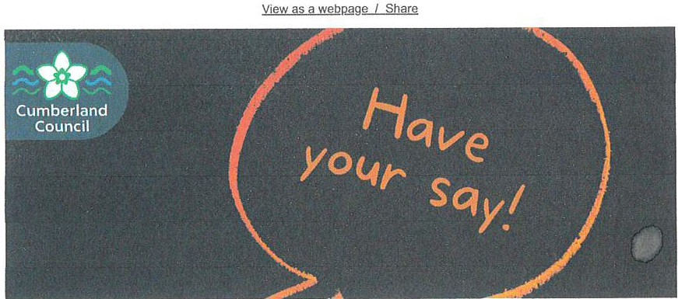

**Whitehaven active travel, wheels and walkways - your Say, your Way**

....

Have your say on proposals for cycling and walking routes in Whitehaven.

As part of the Local Cycling and Walking Infrastructure Plan (LCWIP), this initiative focuses on improving infrastructure for cycling and walking

I*1-J('*

from Whitehaven Harbour to Esk Avenue, on Coach Road and The Gardens. The improvements will promote active and sustainable travel while creating safer routes for residents and visitors.

Demonstrating local support for the proposals is crucial in securing funding from the Department for Transport to deliver the infrastructure improvements.

The consultation will run for four weeks, from Friday 10 January 2025 to Sunday 9 February 2025.

There will be two drop-in events scheduled on Thursday 30 January 2025:

* **Morning session:** United Reformed Church Rooms, Whitehaven, 10am-2pm
* **Afternoon session:** St Begh's Social Centre, Whitehaven, 2.30pm- 6.30pm.

Please do attend these events if possible or complete an online survey to share your views.

There will also be two online sessions via Microsoft Teams on 16 and 22 January to talk through the plans and provide any additional information people may require. These sessions will also include an opportunity for questions. Register to join either the afternoon session on 16 January or the .eYfill.i.!]g...s.essi.on on 22 January.

The consultation is a vital step in ensuring the project reflects the community's needs and priorities.

**Shape the future of bus services in Cumberland**

We're gathering community feedback on preferred destinations, frequency of routes, and ideal bus travel times. Your input will guide improvements and help

**.onc1u·o th.ot n11hlir tr.oncnnrt.otinn mo,otc tho nooric nf .oil rociriontc**

- -**v,,** -**........,**-**...,** "' .... **I"'... .., .. ..,, .................,u ... ,..,,,**-**,,, ..**-**..v, ....** , ...... ,, **,u.v,**

By taking part, you'll help us refine current routes and plan for future services. Your voice matters-complete the survey today and help make public transport better for everyone!

**Why your views matter**

Your feedback is crucial in making sure our services meet the needs of all residents, and will play a key role in determining where improvements and funding are focused. By sharing your views, you'll directly influence the future of public transport in our area and ensure ii works for everyone.

###### Car parking surveys - Carlisle and Keswick

Residents, businesses, organisations and visitors are also being encouraged to take part in our survey to help us understand people's use of and views on local car parks.

The surveys are initially focused on car parking in Carlisle and Keswick, with other areas of Cumberland to follow at a later date, and **will be open until Friday, 31 January.**

We're hoping to gather opinions of the parking options in both locations. users' reasons for using the car parks, value for money, how sites could be improved and more.

The information gathered will help us as we develop a parking strategy; looking at how it can best manage and use the car parking assets we own as well as provide the necessary parking required in different locations.

###### Other consultations

These are just some of the consultation we currently have ongoing at the moment.

There are many other live activities at the moment. These are:

.,.

Have your say!

**m**•**bo**•**rtnnd**

**Coune1I**

**Cu**

* Holiday Activity and Food (HAF) programme - Winter 24 - Cumberland
* Holiday Activity and Food (HAF) programme - Winter 24 - W&F
* WELL Grant Acceptance and Implementation Plan 2024-25 Upload
* Home Adaptations and Assistance
* Shared Lives Service Users Feedback Questionnaire

***\·l***

**A**

**Cumberland Council**

**Closes 9 Feb 2025**

Opened 10 Jan 2025

**Contact**

0300 373 3730

## Overview

We're gathering community feedback on proposals to improve Active Travel in Whitehaven. The term active travel is often used interchangeable with walking and cycling but it also covers

wheeling. Wheeling means trips or journeys made by wheelchair, mobility scooter, roller blades / skates and scooter or using a rollator mobility aid.



The proposals cover sections of two routes identified as a priority in the Whitehaven Local Cycling and Walking Infrastructure Plan (LCWIP). The routes run from Whitehaven Harbour to Esk Avenue and Coach Road to Corkickle Station.

In this questionnaire we have split the proposals into two areas:

* Area 1 includes Whitehaven Harbour to Preston Street car park, via Quay Street, Swingpump Lane, New Town and Preston Street.
* Area 2 includes Preston Street to Esk Avenue via the off-road cycling and walking path, Coach Road east of Friendship Way / Whitehaven Miners Social Centre, and The Gardens.

The route between the Harbour and Esk Avenue is also part of National Cycle Network Route 7, which is the Sea to Sea (C2C) cycle route than runs from Whitehaven to Sunderland and Tynemouth.

Images and plans are available in the files below. These also appear in each part of the consultation.

# Ways to find out more

You can also join us and speak to officers at the following times and locations:

We will have two drop in events in Whitehaven on the 30 January 2025

* 10am to 2pm in the Whitehaven United Reformed Church Rooms on James Street, CA28 7HZ
* 2:30pm to 6.30pm in the St Beghs Social Centre on Coach Road, CA28 7TE

We will also be holding a webinar for those who can't make it but would like to hear more about the schemes. Please sign up to attend. It is free and will be held on Teams (please note that a webinar that was planned for 16 January has had to be cancelled. Apologies for any inconvenience):

* 7pm to 8pm on 22 January 2025 - sign UR to this free event

# Why your views matter

Your views will help us refine the proposals so that they meet the needs of the community. We want to hear from as many people as possible.

Completing the questionnaire is voluntary and all the information you provide will be treated in the strictest of confidence. No information will be released that could identify an individual, household or organisation.

**Give us your views**

Online Survey >

**Related**

Whitehaven cycling and walking scheme = Qian 1

1.5 MB (PDF document)

Whitehaven cycling and walking scheme - Rian 2

879.0 KB (PDF document)

Whitehaven cycling and walking scheme - plan 3

1.5 MB (PDF document)

Whitehaven cycling and walking scheme - Qian 4

1.9 MB (PDF document)

Whitehaven cycling and walking scheme - Qian 5

1.7 MB (PDF document)

Cross Section A - SwingQumQ Lane

1.7 MB (PDF document)

Cross Section B - Preston Street

573.9 KB (PDF document)

Cross Section C - Coach Road

12.8 MB (PDF document)

Cross Section D - The Gardens

1.0 MB (PDF document)

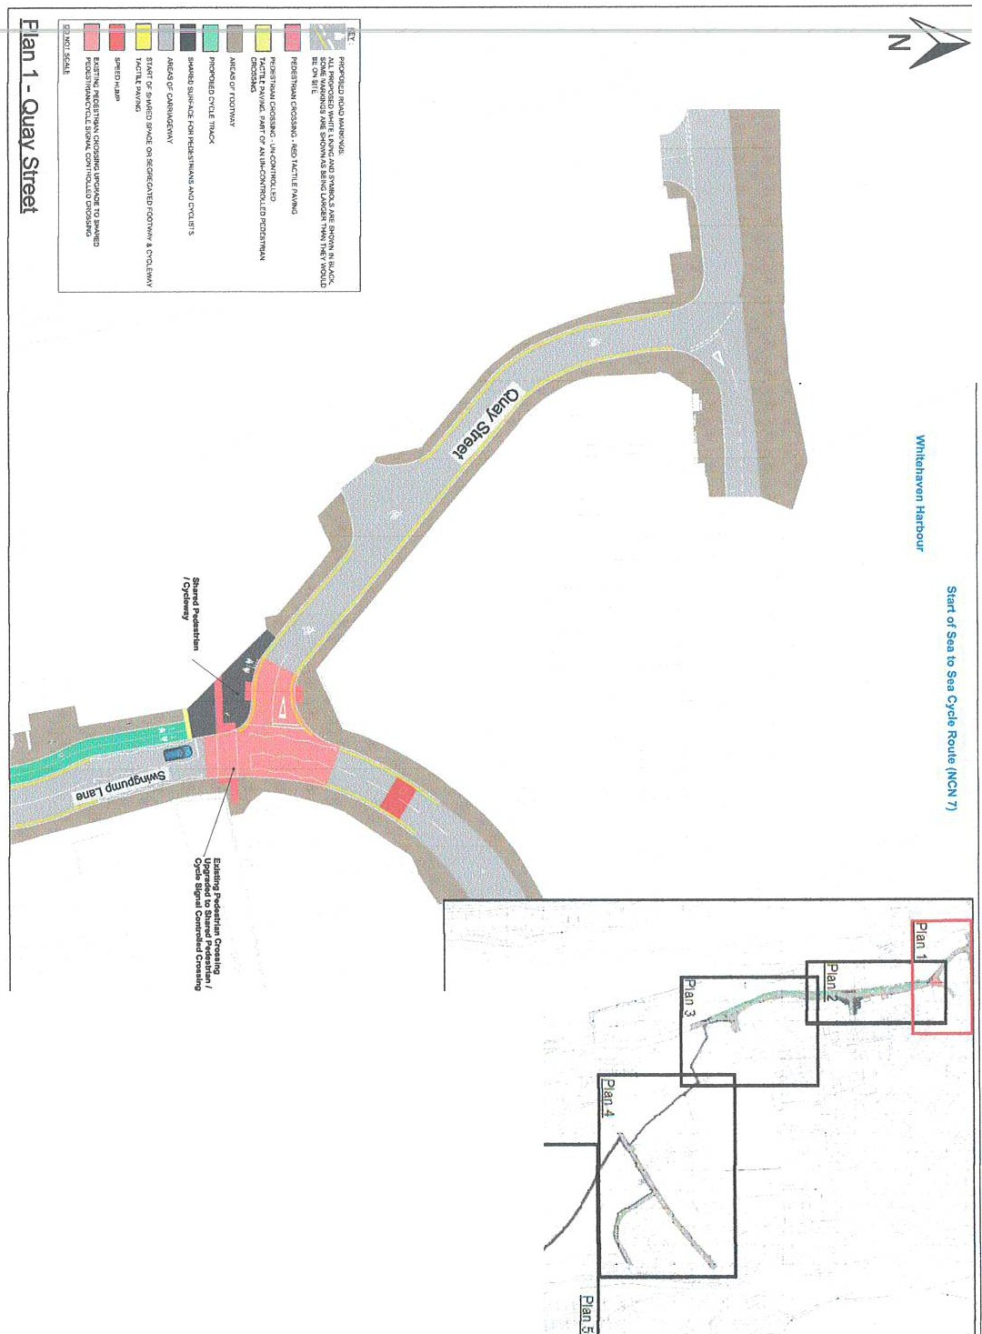

J

i

*I*

i

--0

<1>

-n

n

*-::r*

3

a

:,

:,

oc

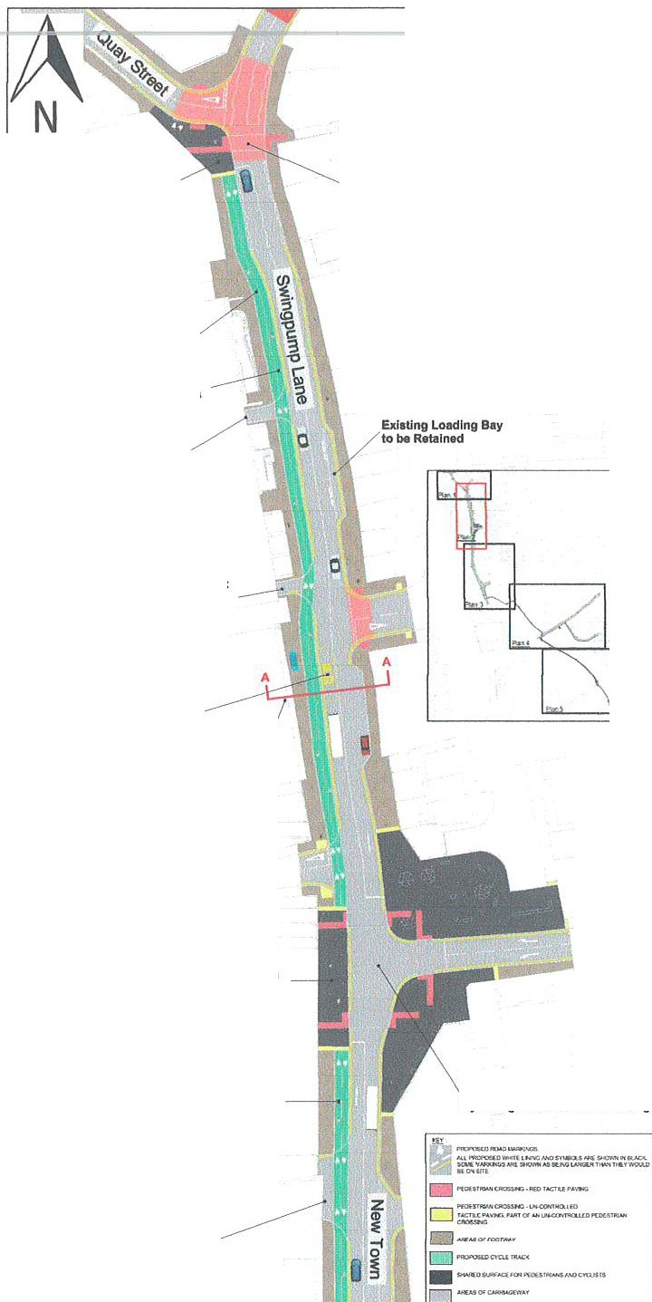

Sharad Pedeltriln ICyelew1y

ExbtlngPedfftr1an Cros1lngs Upgrtdedlo Shared Pedff:trtan *I* Cyde SlgnalControUed Croulng

New 2-way **11e9.. gatod** Cyele Track

Removal of

Existing LoadingBay•

Accas FromCar Par1t lo be Retained

Four Seasons Car **Park**

Aceento car Park to

Exl1Ung Bus Layby to be Removed

and New Cyda Friendly

But Border Provided

Cross SectJonA: Swlngpump Lana

Irish Street

SharedPedestrian

/Cycleway

Naw2-way **Sogregatod** Cyde T,ack

Ext.ting PedHtrian Croselnge Upgraded lo SharedPadastrfan *I* Cycle SlgnllControlled Croaalng

Acceaa toBuslnesaes to N Rea.l.-d

□ ,,,,_..,o,<_-.r:,""'"g,11. 1 o«1•..••• r...•

Plan 2 - Swingpump Lane and New Town

---

c;:;a:- --

I(

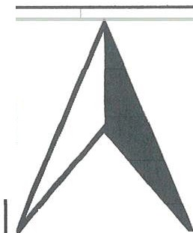

I

\ l \

\ l \

\

\ \

I

\

\

\

l t·

\

I

l

\ j_

\ \

l I\

I

\

l l

**N**

' \ --

\\

- -- _l\

I I - J_ .. --- -

I

\ \

\ -,\ I

\ ---,

l" ,,.

1

\ L_, J

l

--.--.

###### Existing E

**Stop Reta**

1

l\ ----

-

###### Access to Businesses

**to be Retained**

,

r-,.,- t-= =-·-\

\ h \

*II*r

*I*

*I I*

I

*I*

*I I* I

*I*

*!*'

###### New 2-way

l

\

:i \

I

###### = Segregated

- - **Cycle Track**

\\

\\

\\

\\

\

\

\

,..-·....-

_., ..-

i ii \l

\ t

, ' \ -- --- -

_-:-·- £0>-<dl \. \

\ c------

\ \

-\

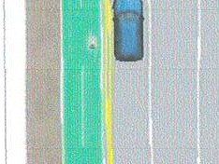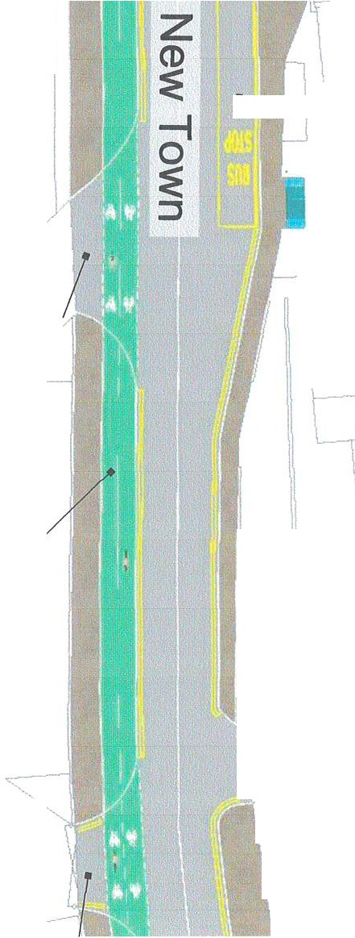

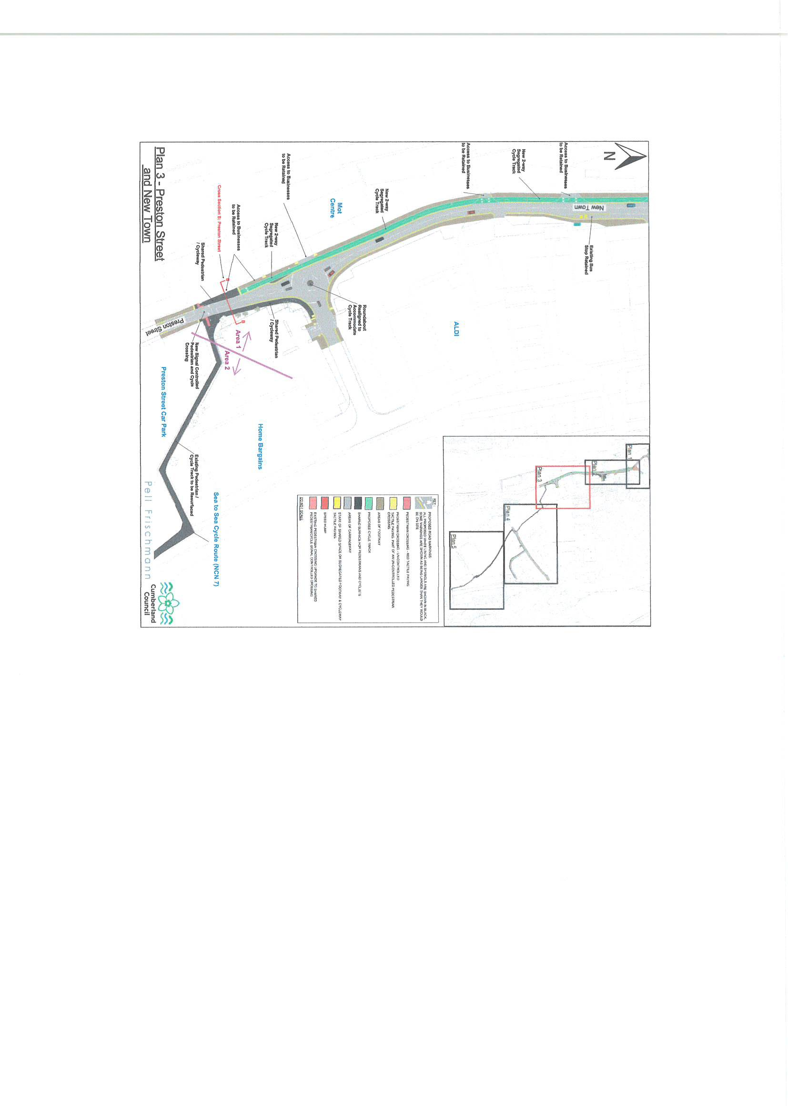

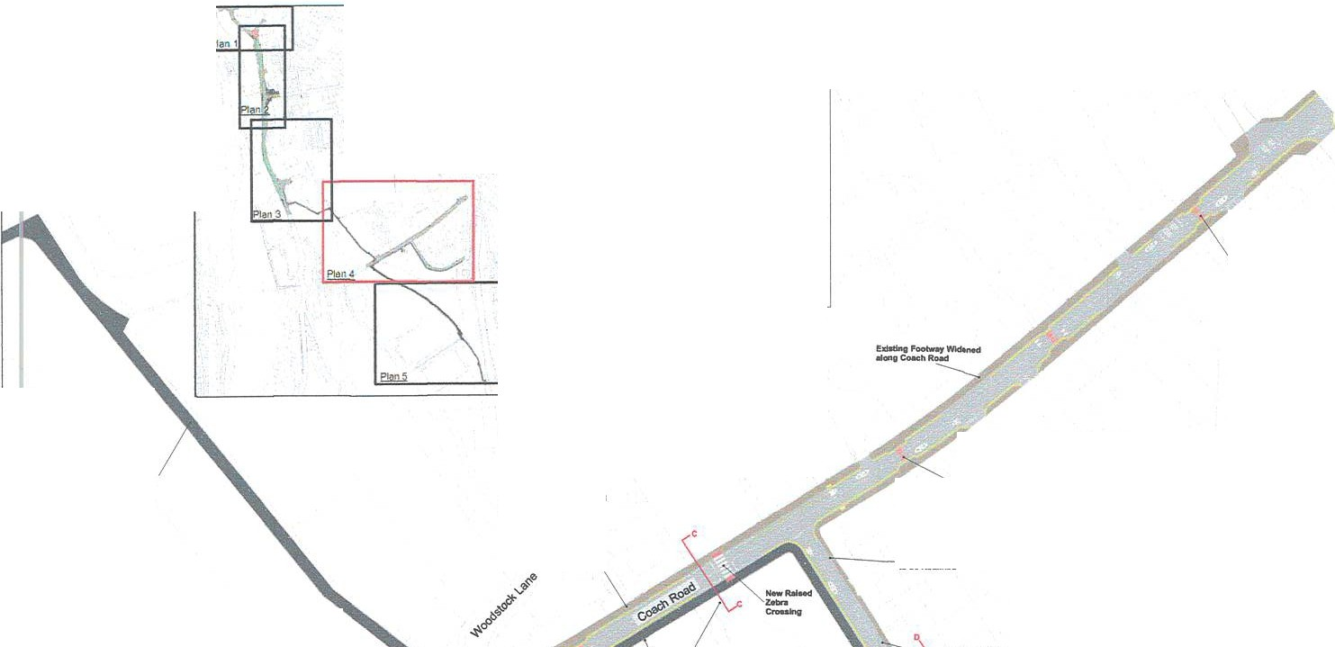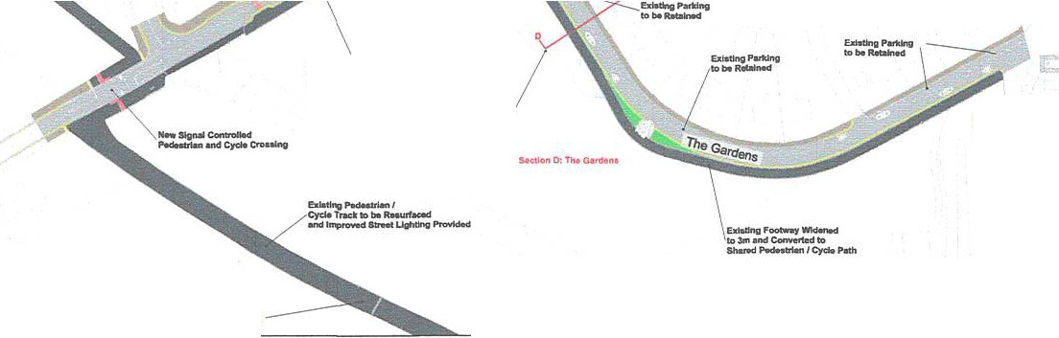

I

- ·

'-=:-o

,,;y

D ,itc,fl,TIWJICA0S51HG."1!0TlrlCft.l""""'1>iG

111:0HSl!ti

D

lCO DtmWo

□l'ftD'OMOC TIUOC

0,f(ICIN\'AY

- -.0_.,IIC\o,()lll l-U/6JCT0..IIIS

DAA£MCl WJ,Y

D

lJAIITO,IHOl'tOtp o,lll(Clt(G,o.KOJOOTW"Y.C\'CUWIIY

u,cn.i; ,.w.o

0

BJ•uc-

...,.,,.,..

,e. Tl9fflc

c---.•-

SL Begh't CathoUc Junior School

......, ,,

T,..,_tolM

---- --

....

-=:ror:cRetal!Wd

-

--­

C•oH*ltdit.n*C:CMch Ro.4

IOSMlnll 10

st\N'M /o,d.Palh

Corklckle Train SUl:tlon --

Whitehaven Mlrwtrs Social c,nt,.

**Rian 4** - **Coach Road and The Gardens**

**,.**w**,e-0--.,...**

Sea to SH Cyckt Route(NCN 7)

Pell Fr schmonn Council

Cumberland

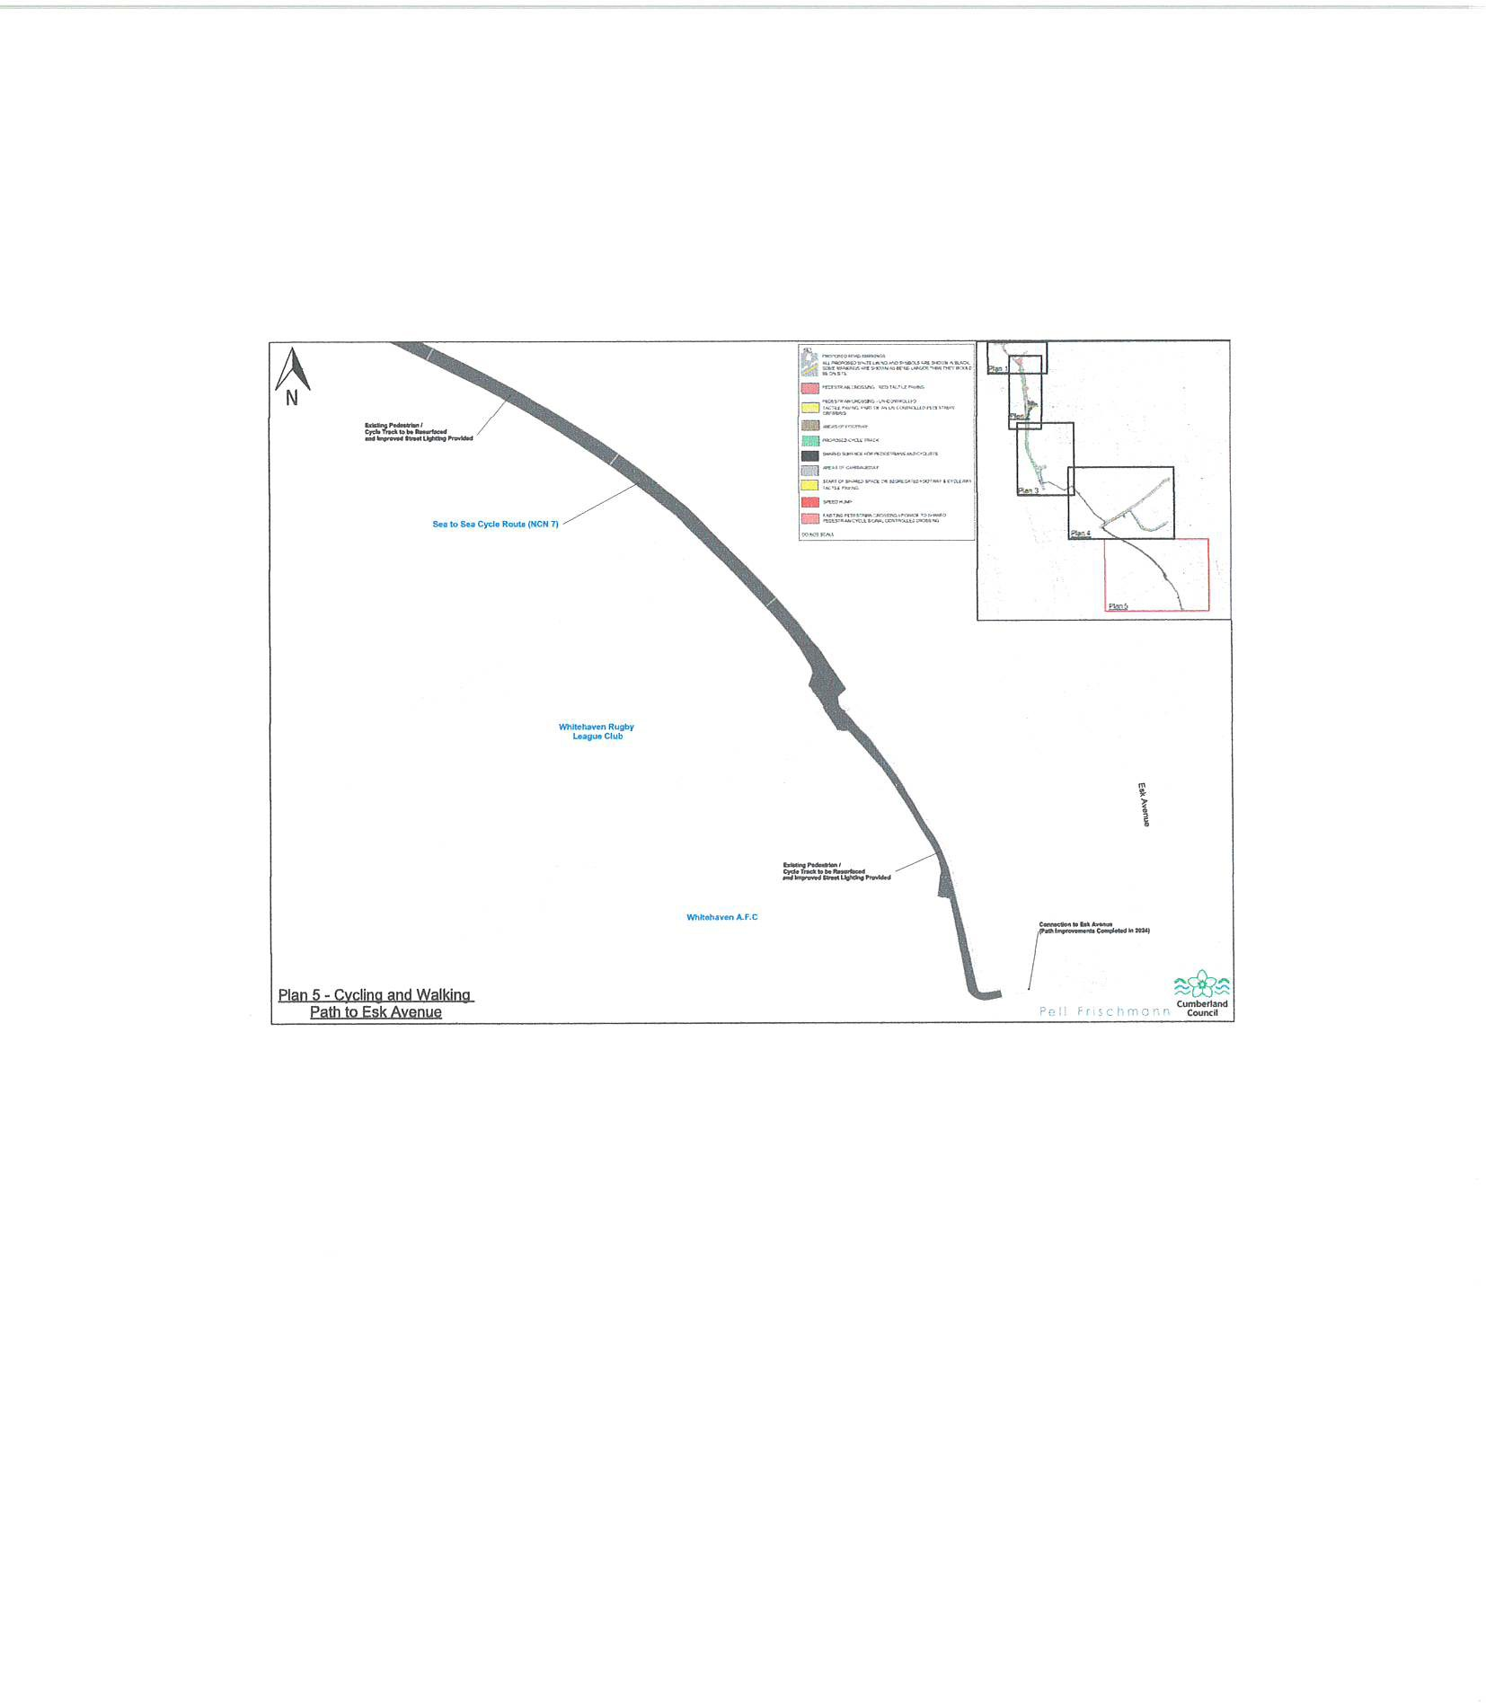

**SWINGPUMP LANE**

".,."..,00,...,...

**Cumberland Council**

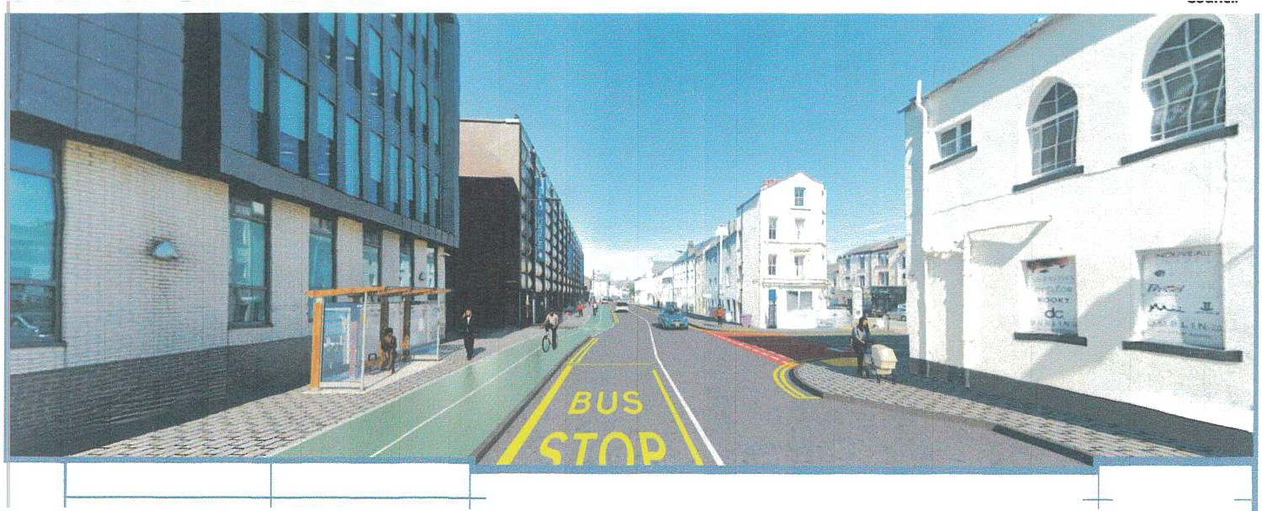

2 8m footway

3 Orn 2-way cycle track

8 9m carriageway (road)

2.4m footway

***r.J***

C-1<-C)ss **C°\\ON *A***

--

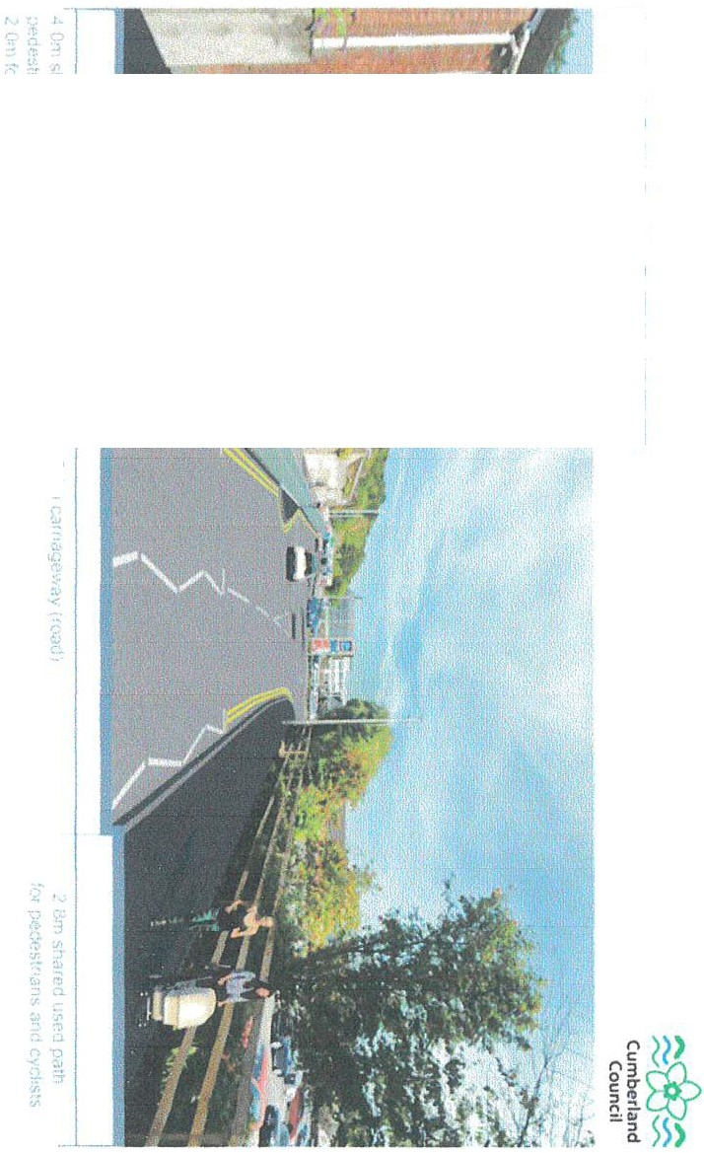

**;o**

**"'C**

m

" •

**0z**

**CJ)**

**-I**

"--

***J***

**CJ)**

**;o**

**-I**

m

m

, ,.

**-I**

f

V\

()

z

(J0

**COACH ROAD**

./'-./ ..,.,,...,._.

**Cumberland Council**

- -

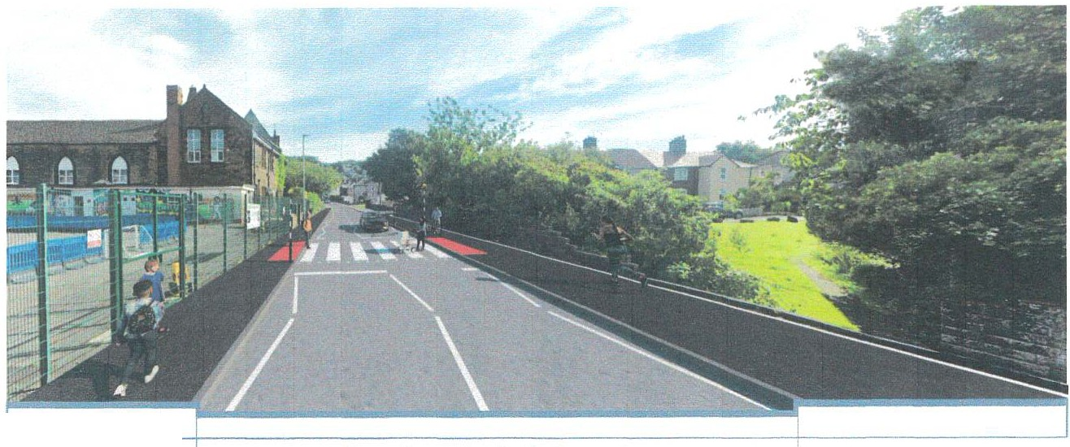

2.3m footway 6.7m carriageway (road) with zebra crossing 3 Orn shared use path for pedestrian and cyclists

CP-oscs. **c-rtoN *c***

~ ..,...

**THE GARDENS** "'ffi"""'

**Cumberland Coundl**

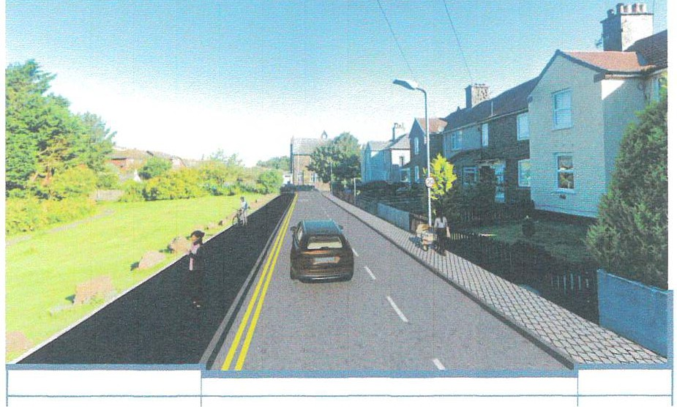

3.Crn shared use path for pedestrians and cyclists

5.5rncarriageway (road) (including 2.1m parking bay)

1.5m footway

***Cp_oss.* C--""T" *l* ON**

**A**

***i•:,",,,***

Cumberland

Council

**Closes 31 Jan 2025**

Opened 24 Oct 2024

**Contact**

01228606060

[integrated.transP-ort@cumberland.gov.uk](mailto:integrated.transP-ort@cumberland.gov.uk)

## Overview

We're gathering community feedback on preferred destinations, frequency of routes, and ideal travel times. Your input will guide improvements and help ensure that public transportation meets the needs of all residents.

By taking part, you'll help Cumberland Council refine current routes and plan for future services.

Your voice matters-complete the survey today and help make public transport better for everyone!

**Why your views matter**

Your feedback is crucial in making sure our services meet the needs of all residents, and will play a key role in determining where improvements and funding are focused. By sharing your views, you'll directly influence the future of public transport in our area and ensure it works for everyone.

**Give us your views**

Online SurveY- >

Audiences

All residents



##### WTC 30/01/2025

**Item 11**

##### EASTER EGG EVENT

**Purpose of the Report**

To ask Members whether or not to hold an Easter Egg event to be funded out of the Mayor's Allowance.

* 1. **INTRODUCTION**
  2. For the past two years the Council has organised an event on either the Saturday before Easter or on Easter Saturday to give away Easter eggs to children. Last year the Easter Bunny, Paw Patrol and Mickey Mouse were helping out and entertaining the children. The funding for the Easter eggs was kindly donated by the Mayor out of his allowance.
  3. It is proposed to hold a similar event this year. Councillor Roberts who has stood down as Mayor for the time being has been contacted out of courtesy about this and has agreed to the cost of the Easter eggs being taken out of the Mayor's Allowance as has Councillor Hayes who as Deputy Mayor has been undertaking Mayoral duties.

##### RECOMMENDATION

* 1. To consider whether or not to hold the Easter Egg event and if so to approve funding for this from the Mayor's Allowance

##### WTC 30/01/2025

**Item 12**

##### QUOTE RECEIVED FROM OCTOPUS ENERGY

**Purpose of the Report**

To ask Members to consider a quote received from Octopus Energy for the electricity supply to the Council's Unit at Sneckyeat Road Industrial Estate.

* 1. **INTRODUCTION**
  2. The Council leases an Industrial Unit at Sneckyeat Road Industrial Estate for storage of equipment. The electricity supplier is E.ON Next. The current charges are:-
     + 47.7p per kWh per hour
     + £2.00 per day Standing Charge
  3. A representative walked into the Council's storage unit just before Christmas and asked about the electricity supplier. As a result of the conversation he send a quote for the supply of electricity to the Unit which is shown at Appendix 1 and their charges are as follows for a 12 month fixed contract:-
     + Unit Rate 24.23p per kWh
     + Standing Charge 47.99p per day
     + Monthly cost projection is £34.78
     + Based on someone in CA28 8PE using 1,000 kWh of electricity the estimated cost is £417.40 per year
  4. The Management Company who administer the Industrial Units on Sneckyeat have confirmed that we do not need their permission to change electricity suppliers or to have a smart meter fitted

##### RECOMMENDATION

* 1. The Council is asked to consider this quote and decide whether or not to change our electricity supplier to Octopus Energy

t,.vTC *3o { o* I /:tS

t-rEM *i.2..*

**Whitehaven Town Council**

**From: Sent: To: Subject:**

Octopus Energy <[hello@octopus.energy](mailto:hello@octopus.energy)> 18 December 2024 09:54

Whitehaven Town Council Your Octopus Energy quote

Energy Heat pumps Solar & battery Electric vehicles

**Your business quote**

**Green Octopus 12M Fixed**

**Electricity**

**Unit rate: 24.23p per kWh Standing charge: 47.99p per day**

Your monthly cost projection is

**£34.78\***

**Based on someone in CA28 8PE using 1**,**000 kWh of electricity**

**That's an estimated £417.40 per year**

**\*Prices exclude VAT and the Government's Climate Change Levy**

Your quote is accurate as of the time of sending. You can always view other tariff options when you return to your online quote.

Prices may change over time, please review the latest price on our website before you switch. All you need complete the sign up is your company details, your bank details and two spare minutes.

We'll take care of the rest.

**Return to m online uote**

1

